# 3. IAM and S3

S3 101:

S3 is build of eleven 9 availability

S3 has:

* Tiered Storage
* Lifecycle management – if a file is x old, do y with it
* Versioning
* Encryption
* MFA Delete
* Secure Data using ACLs and Bucket policies

1. S3 Standard – eleven 9 availability where the loss of 2 facilities concurrently can be sustained
2. S3 IA- Infrequently accessed. Lower charged storage that is accessed infrequently. Retrieval fee is charged
3. S3 One Zone IA – lower cost option for infrequently accessed data where multiple AZs are not required
4. S3 Intelligent Tiering – designed to optimize cost by automatically moving your data to appropriate S3 Tier
5. S3 Glacier – Low cost storage for archiving. Retrieval time is minutes to hours
6. S3 Glacier Deep Archive – Cheapest storage. Retrieval hours on the order of 12 hours

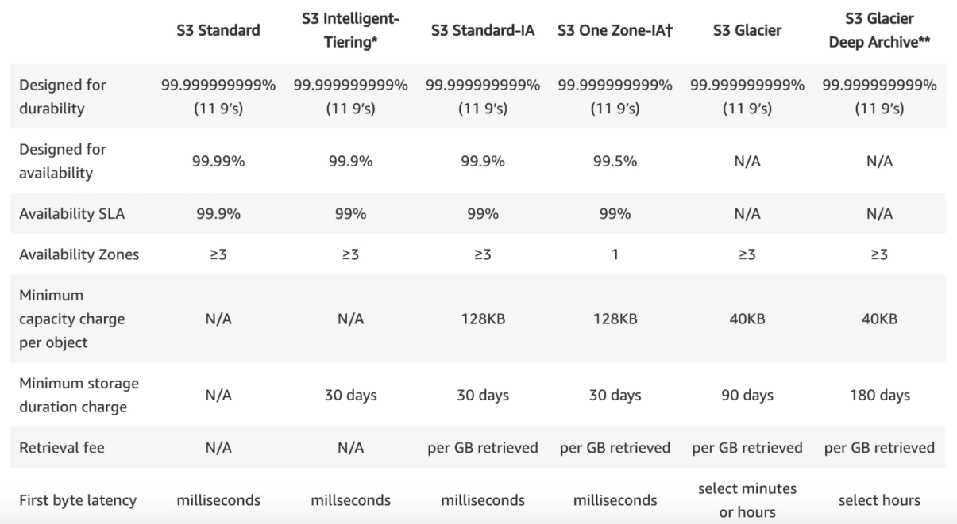

Know – First byte latency

For S3, you’re charged for

* Storage
* number of requests
* storage management pricing
* data transfer pricing
* Transfer Acceleration
  + The user uploads file to the Amazon edge location and that data is routed to the data center over the Amazon backbone network path
* Cross Region Replication Pricing

**Exam Tips:**

* S3 is Object Based (vs block based – os and db)
* Files can be 0 to 5Tb
* Unlimited storage
* Buckets
* S3 is universal namespace (converts to a DNS name)
* Can’t install OS on S3
* Successful uploads will generate HTTP 200 code
* Can turn on MFA Delete

Key fundamentals of S3:

* Key
* Value
* Version ID
* Metadata
* Sub resources
* Access Control Lists (bucket and object level)
* Torrent

Read after Write consistency for PUTS of new Objects

Eventual Consistency for overwrite PUTS and DELETE – can take time to propagate

Different Storage classes (Table Above)

Go read the S3 FAQs before the Exam!

S3 Pricing Tiers:

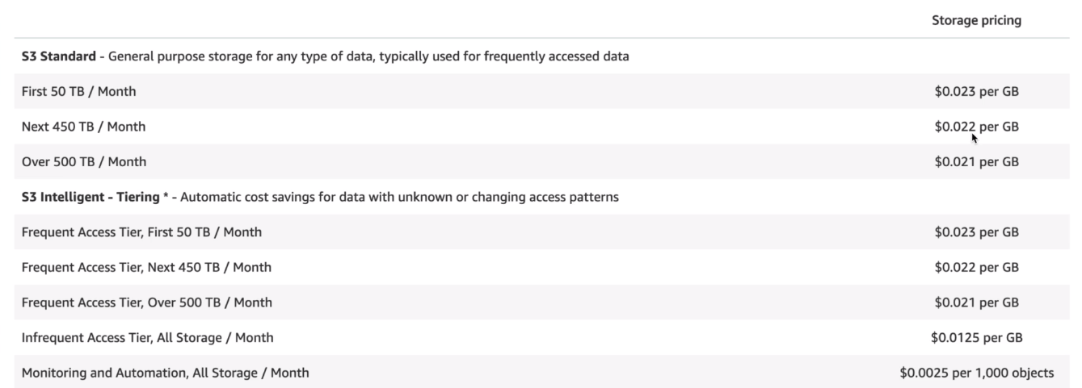

Size of s3 bucket is sum total of all the versions of a file it contains.

**S3 Versioning Version Control Tips:**

* Stores all versions of object
* Great backup tool
* Once enabled, versioning cannot be disabled, only suspended.
* Integrates with lifecycle rules
* Versioning MFA Delete capability exists

Different ways to share s3 buckets across accounts:

* Using bucket policies and IAM (applies across entire bucket). Programmatic access only
* Using Bucket ACLs and IAM (Individual objects). Prog accesso nly
* Cross-account IAM Roles. Prog and Console access

**s3 replication** doesn't replicate old objects

s3 replication doesn't replicate deletes

cross region rep (CRRO) - versioning must be enabled on source and destination buckets

**S3 Transfer Acceleration:**

**Cloudfront is a CDN:**

* Edge location is a location where content is cached
* Origin is the location of the data
* Distribution is name given to CDN which consists of various Edge locations
* Web Distribution – used for websites
* RTMP – used for media streaming

Edge locations are not just read only – can write to them

Objects are cached for the life of the TTL (Time to live)

You can clear cached objects from an edge location, but are charged for them.

**Snowball**:

Petabyte-scale transport solution. Getting data into and out of AWS.

Can have 50TB or 80TB.

Snowball Edge is 100TB data transfer service with on-board compute capabilite.s

Storage Gateway (store stuff in s3):

Types:

* File Gateway (NFS and SMB)
* Volume Gateway (iSCSI)
  + Stored Volumes (OS or hdd images) – Entire Dataset is stored on site and asynchronously backed up to S3
  + Cached Volumes – entire dataset is stored on S3 and most frequently accessed data is cached on site
* Tape Library

**Athena vs. Macie**

* Athena: Interactive query service which enables you to analyze and query data in S3 using standard SQL
  + Serverless, pay per query and per TB scanned
  + Don’t need to set up complex Extract/Transform/Load (ETL) processes
  + Works directly with data stored in s3
  + USE CASES: query log files in s3,
    - generate business reports on data stored in s3
    - analyze aws cost and usage reports
    - run queries on click-stream data
* Macie: Security service which uses NLP to discover classify and protect sensitive data in S3
  + Use AI to recognize if s3 objects contain PII
  + Dashboards, reporting, and alters
  + Works directly with data stored in s3
  + Can analyze Cloudtrail logs
  + Great for PCI-DSS and preventing ID theft

IAM and S3 Summary:

* Mostly covered above. Again read s3 FAQ

# 4. EC2

*Security Groups* are stateful. NACLs (VPC section) are stateless. In security groups, when an inbound rule is created, and outbound rule is created automatically (stateful).

* You need proper security group setting on the side of the request originator (responses come free)
* You cannot **block** IP addresses using security groups (use NACLs instead)

*Elastic Block Storage (EBS)* –

* Each EBS volume is replicated automatically within its AZ

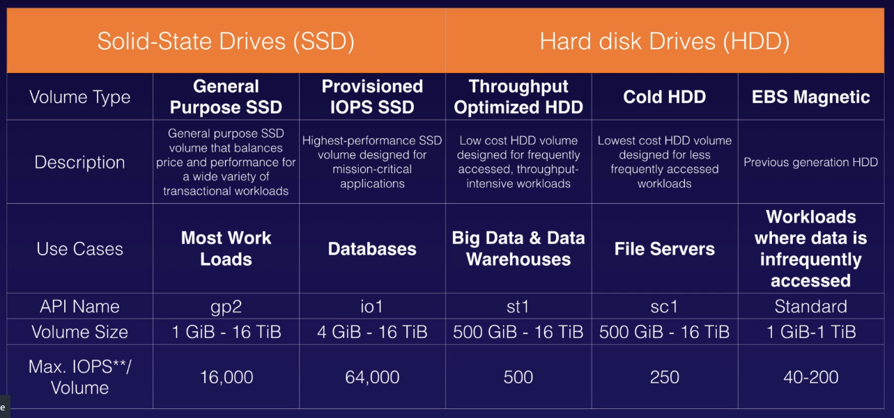

** know the API name row for above table **

* The EBS volume attached to an instance needs to be in the same AZ
* To move an EBS volume from one AZ to another, create a snapshot and create an AMI. Use the AMI to launch instance in different AZ
  + Can copy AMI by selecting AMI > Actions > Copy AMI > Fill out Destination, Name, Description

AMI types (EBS vs. instance store)

* AMIs are categorized as backed by Amazon EBS or instance store
* The root device of an ec2 is EBS if created from EBS snapshot, and it is and instance store volume if created from a template stored in S3

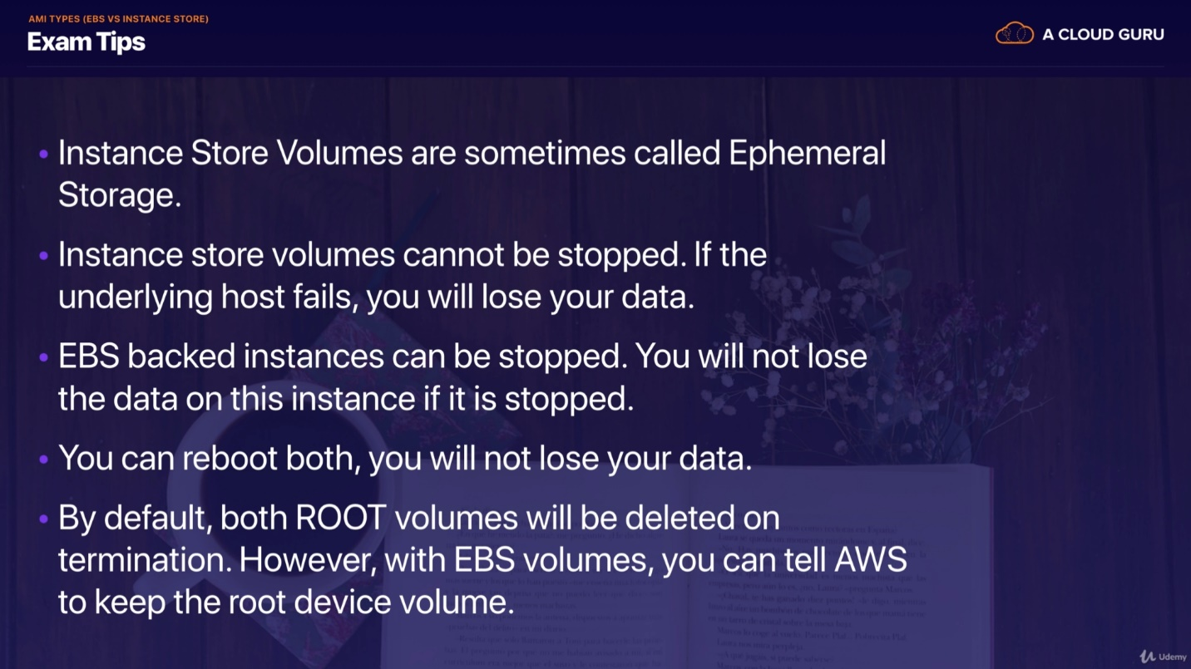

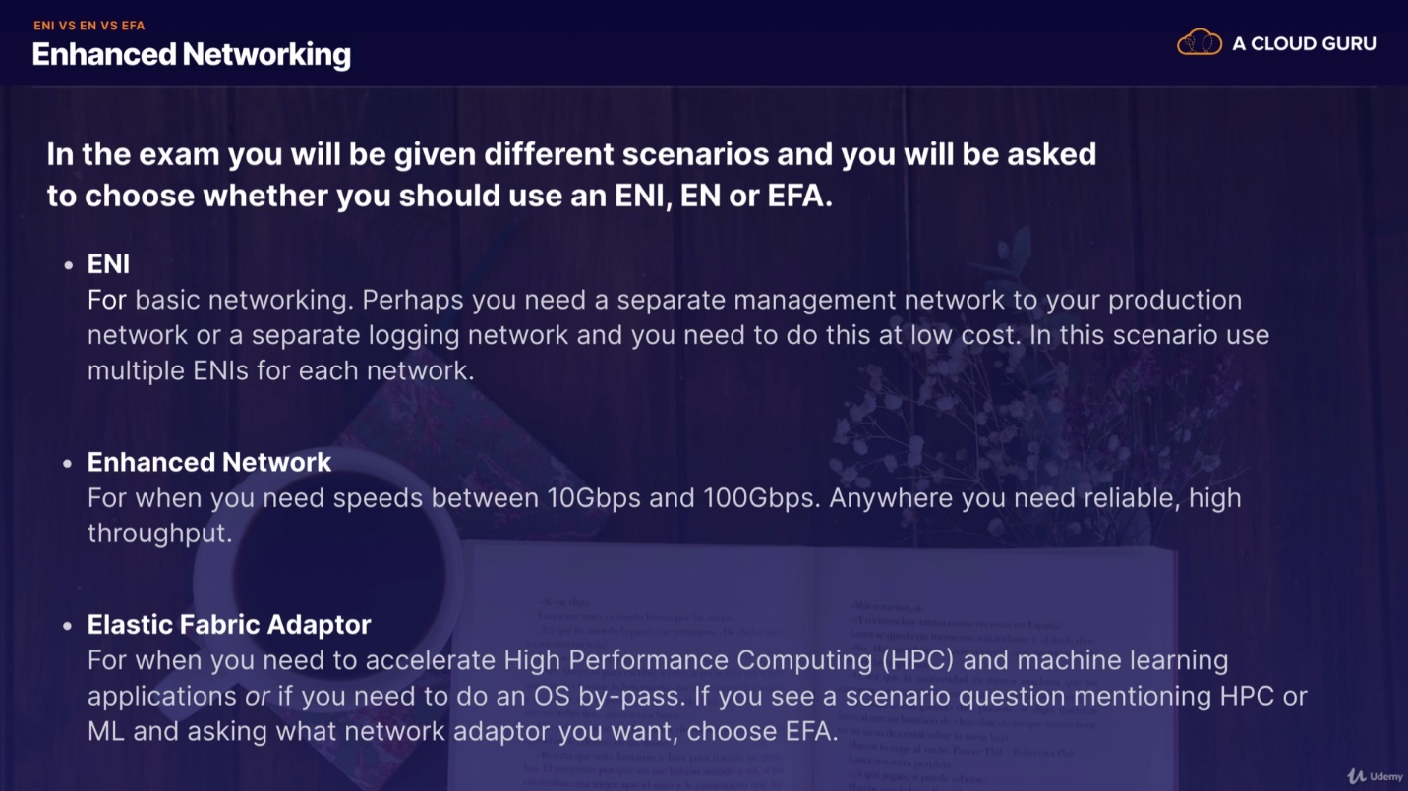

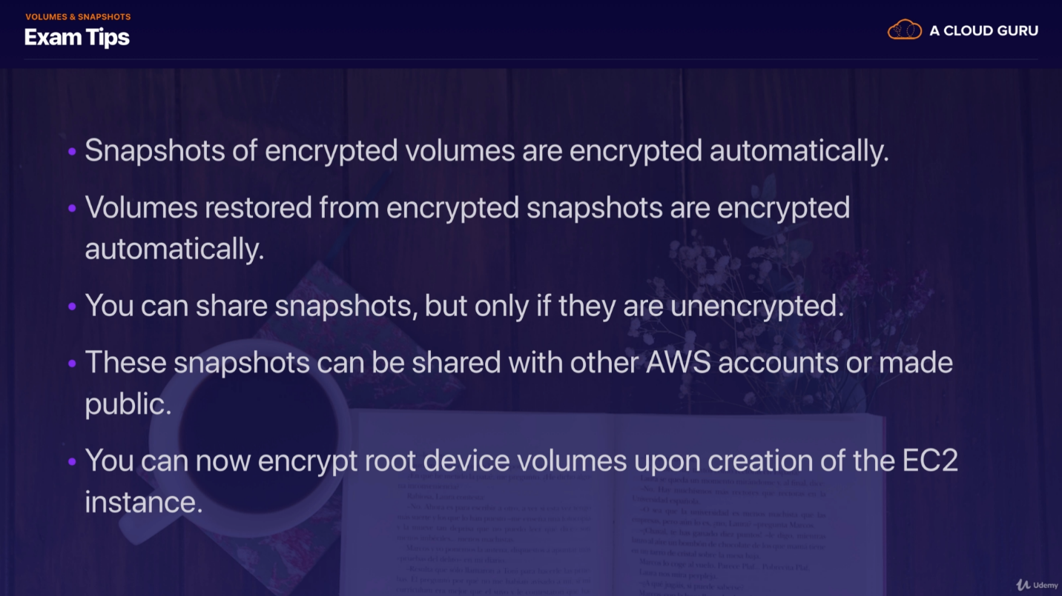

Encrypting an unencrypted root volume

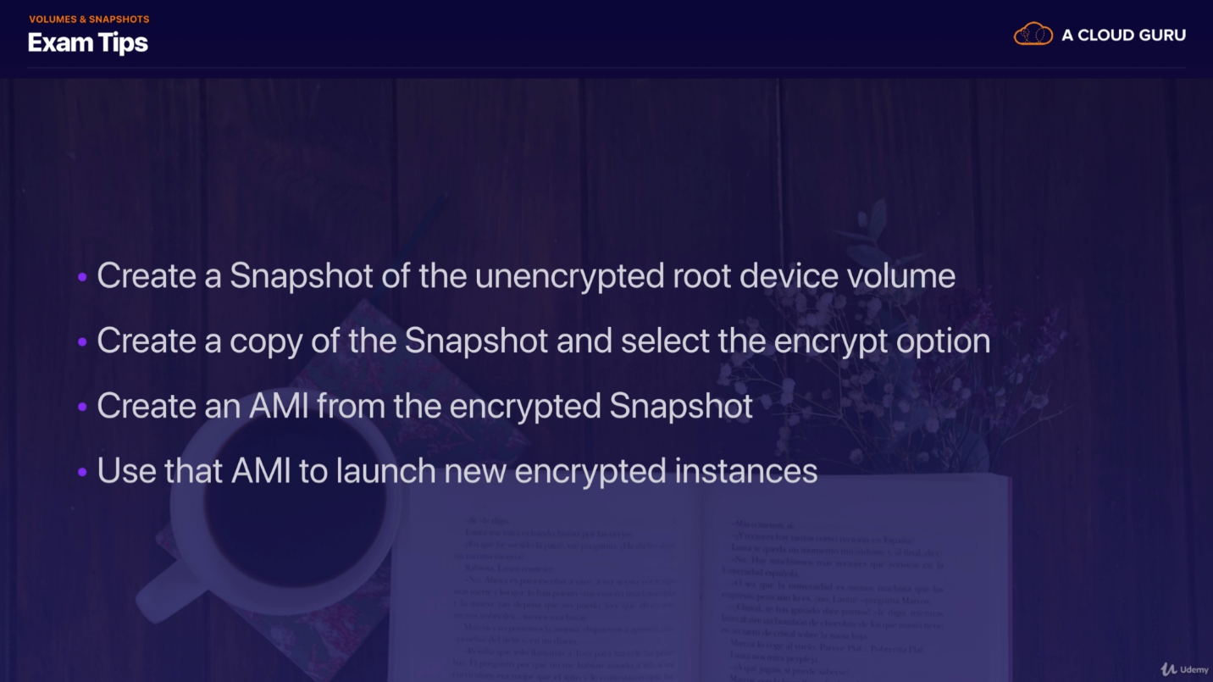

**Spot instances:**

Spot fleet is a collection of spot instances

You can block spot instances from terminating using spot block

**CloudWatch vs. CloudTrail:**

Cloud watch is resource performance monitoring whereas Cloud Trail is monitoring (auditing) AWS Console and API calls (records IP, time, etc.)

* Cloudwatch can monitor at a minimum of once per minute

Stopped at: Bootstrap/bash scripting

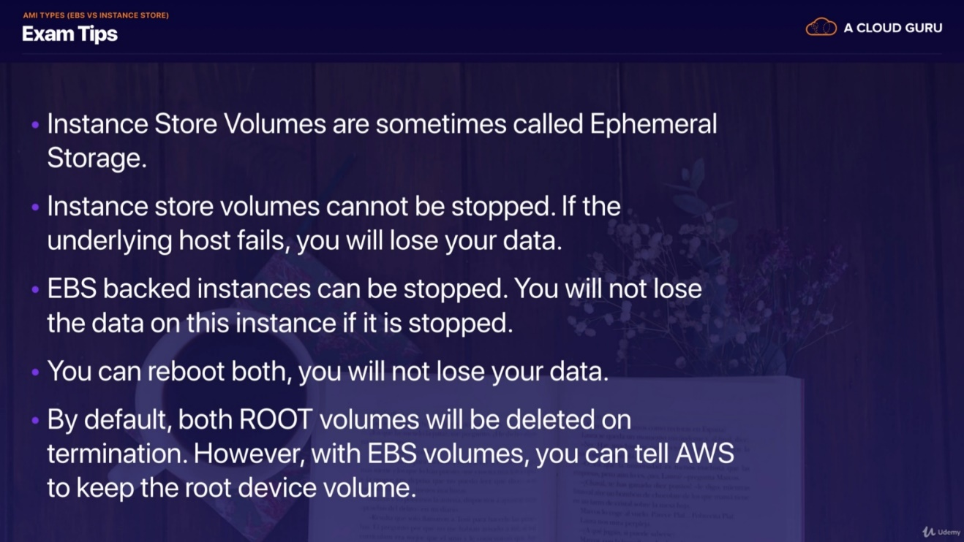

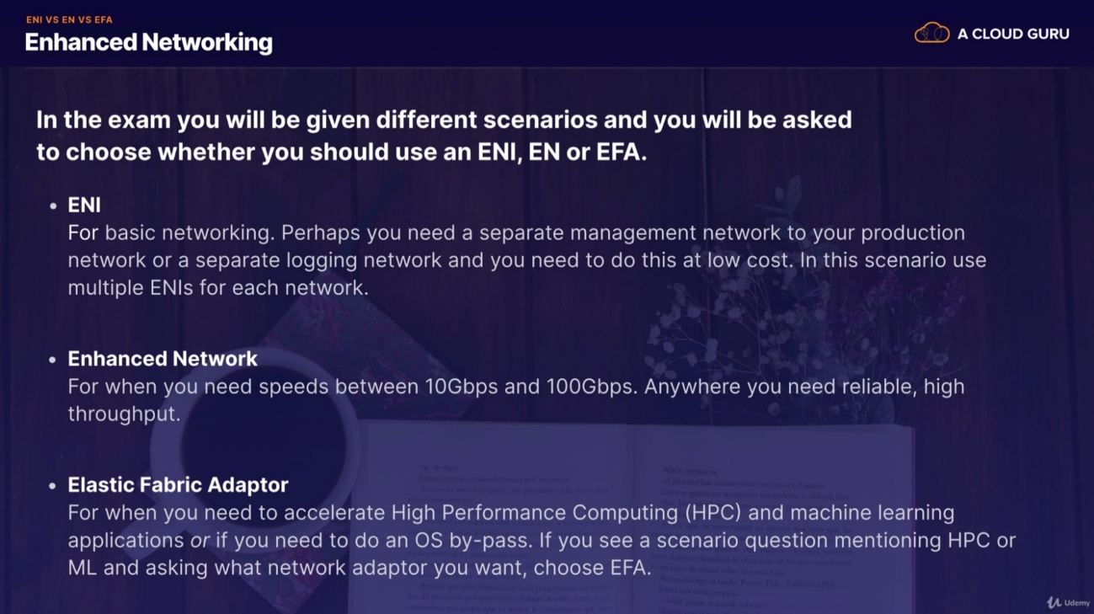

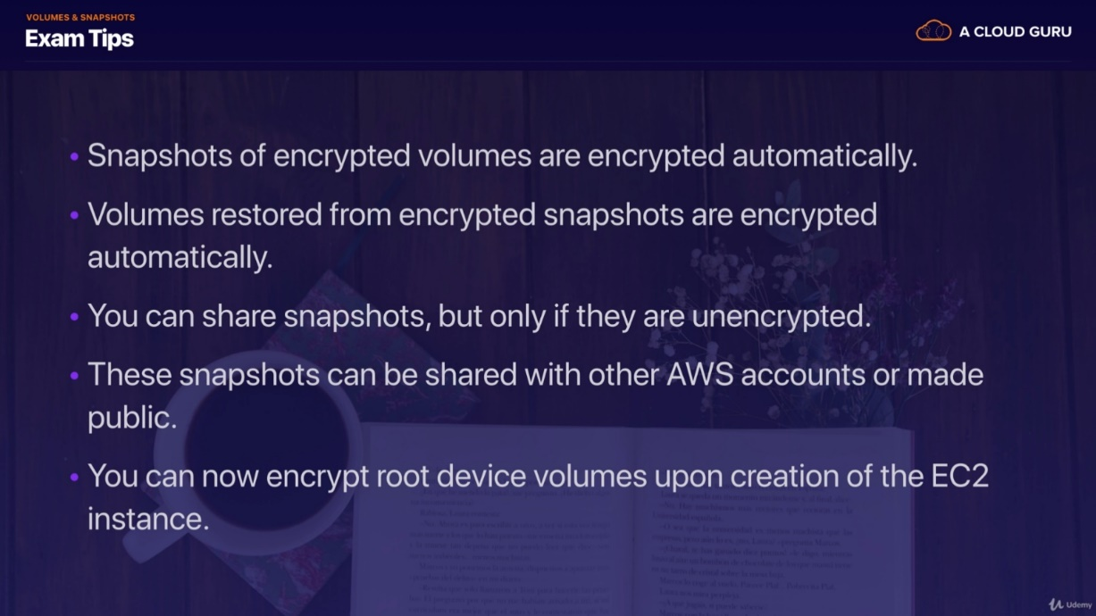

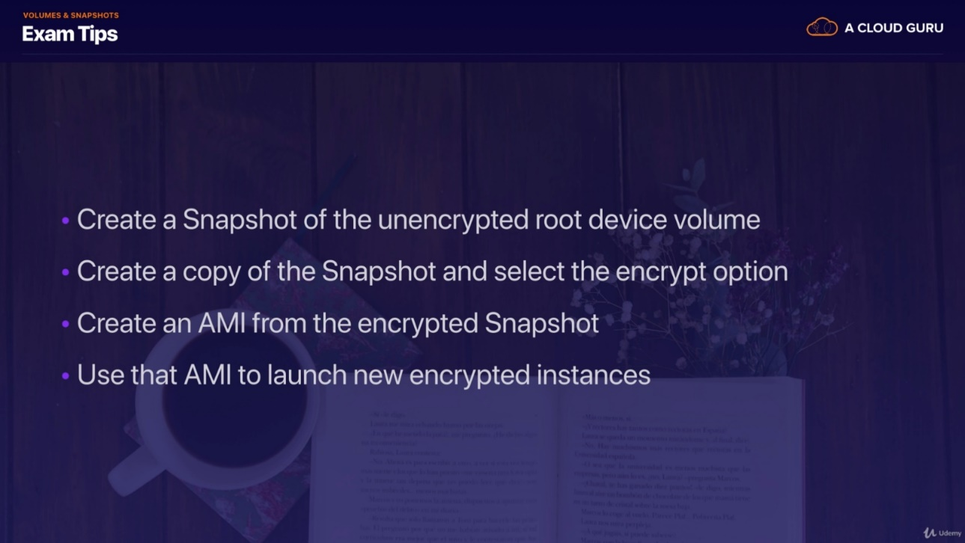

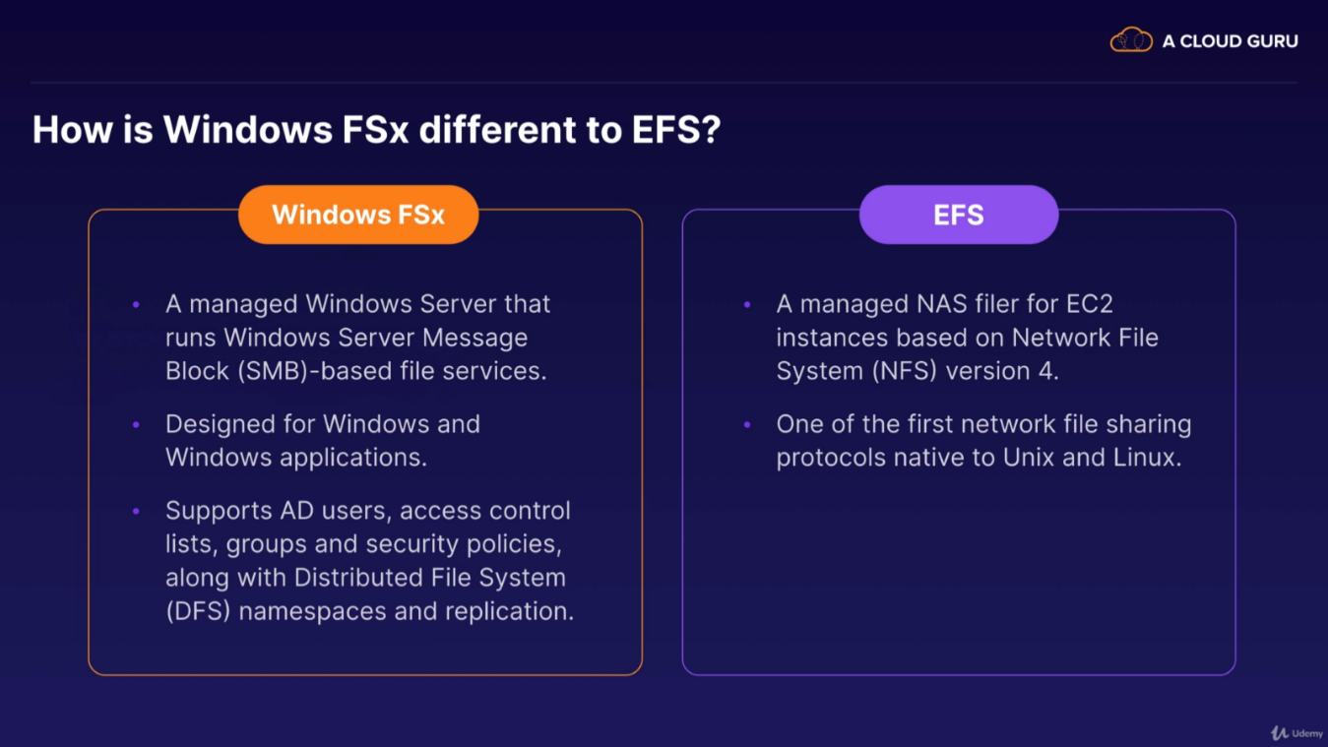

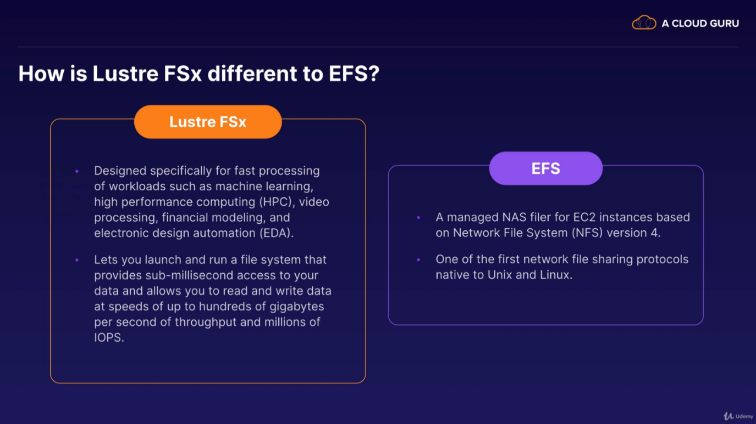

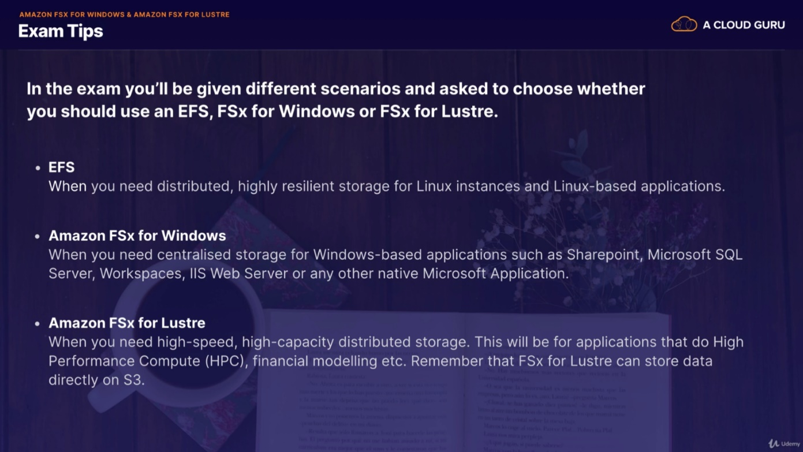

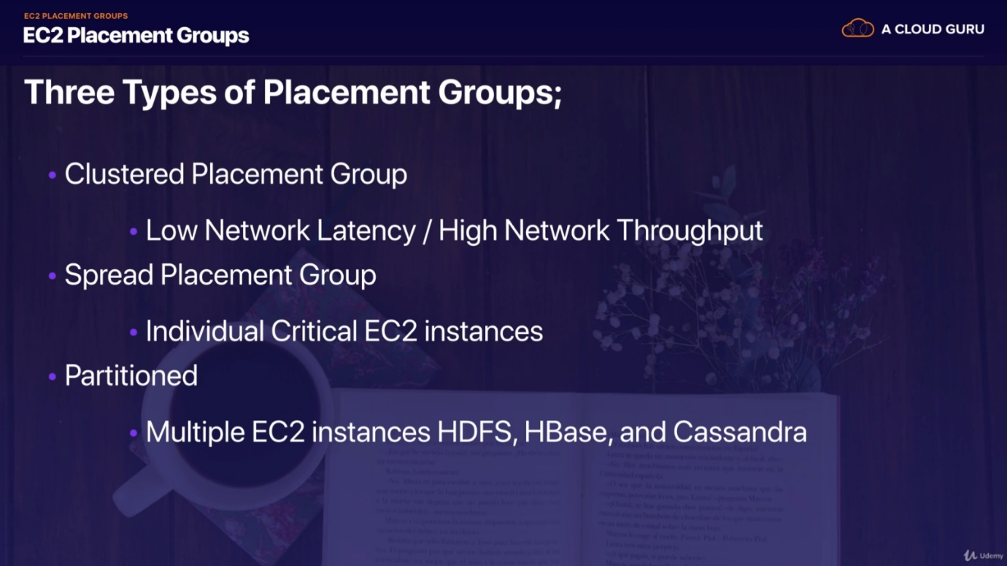

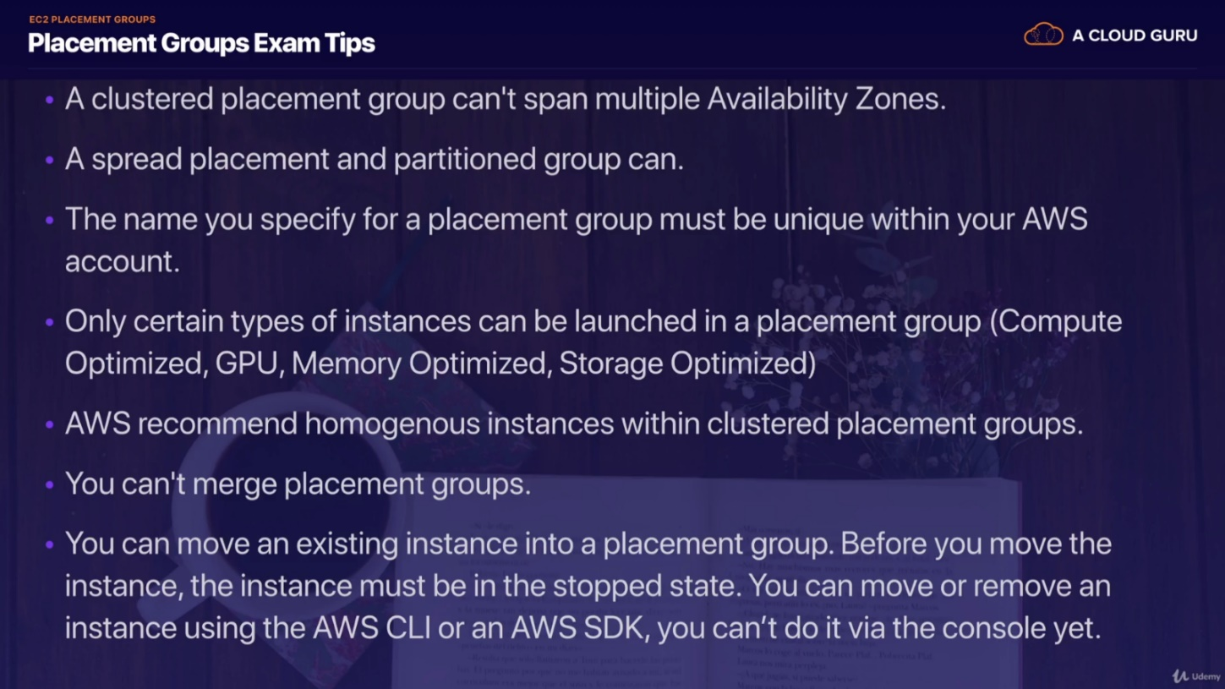

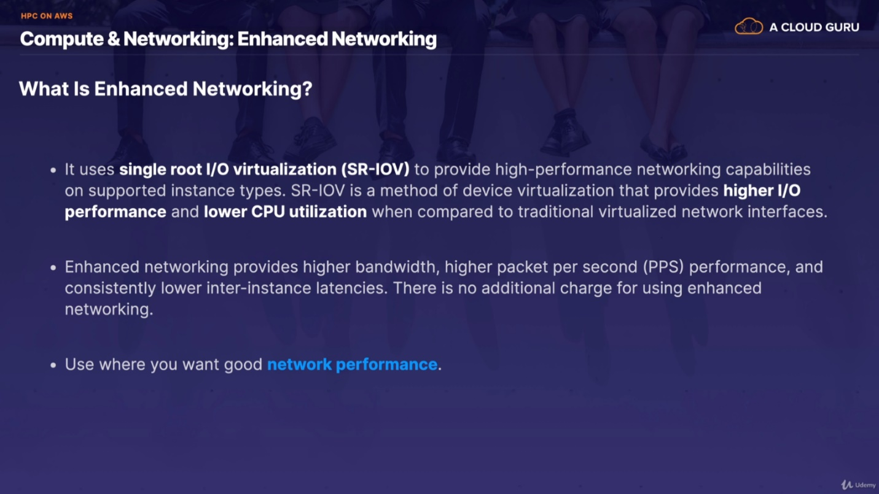

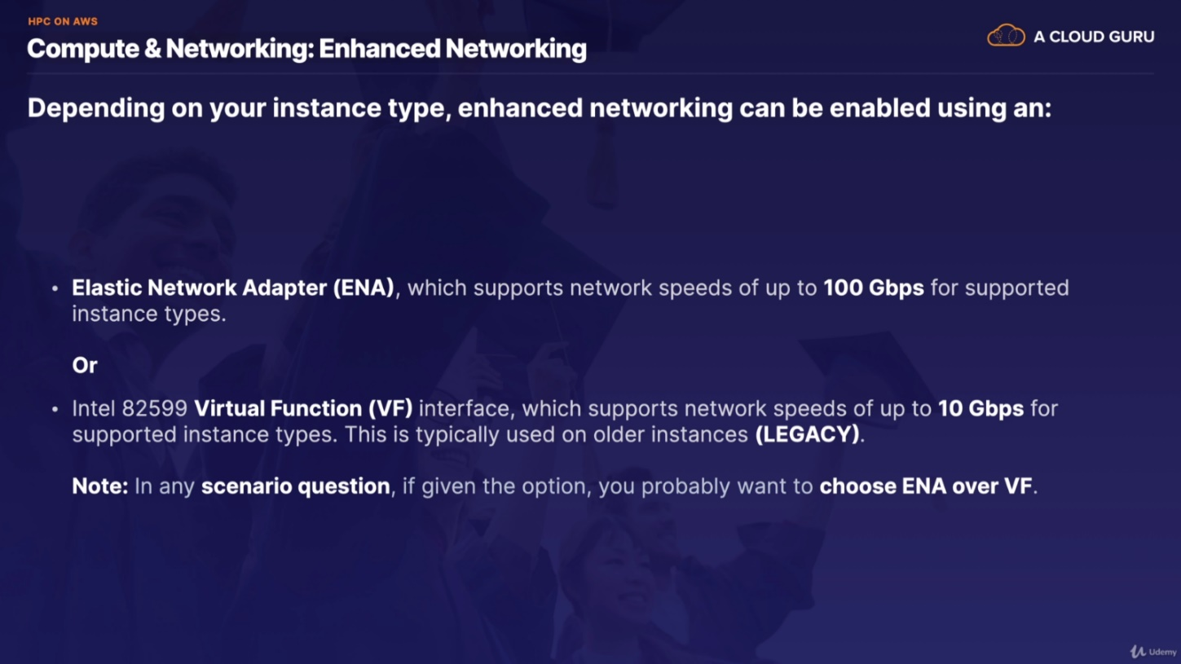

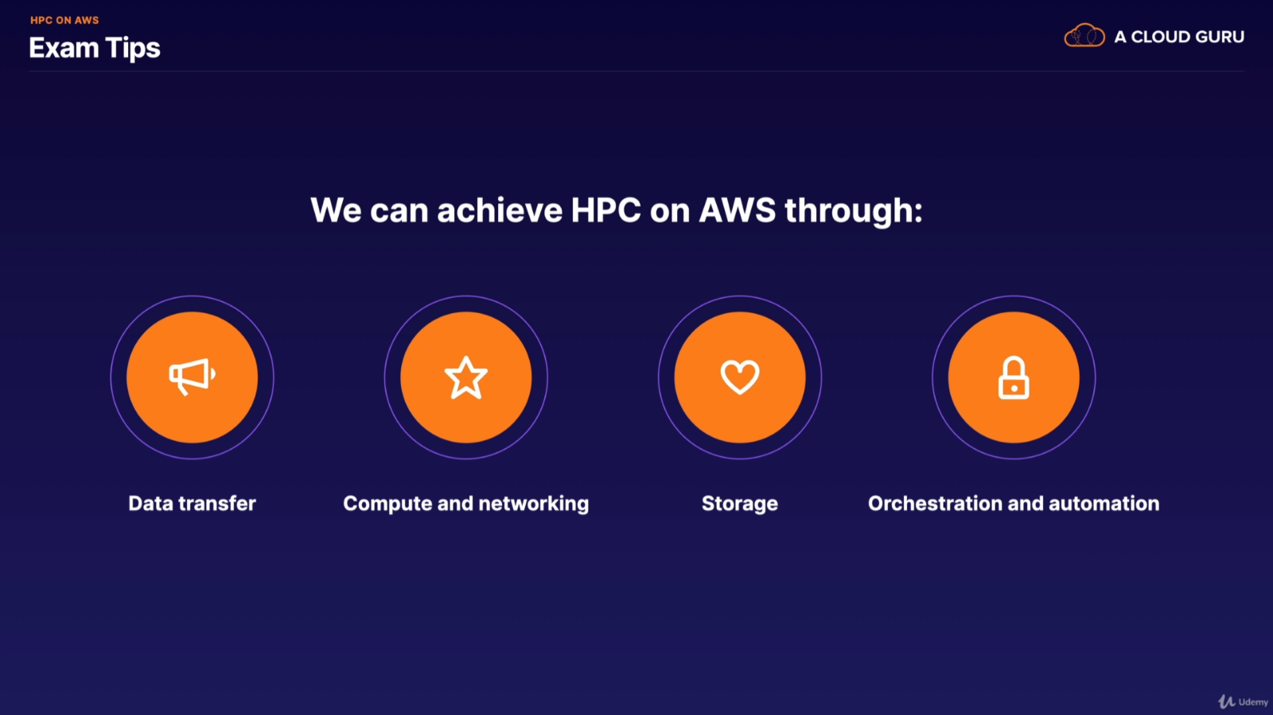

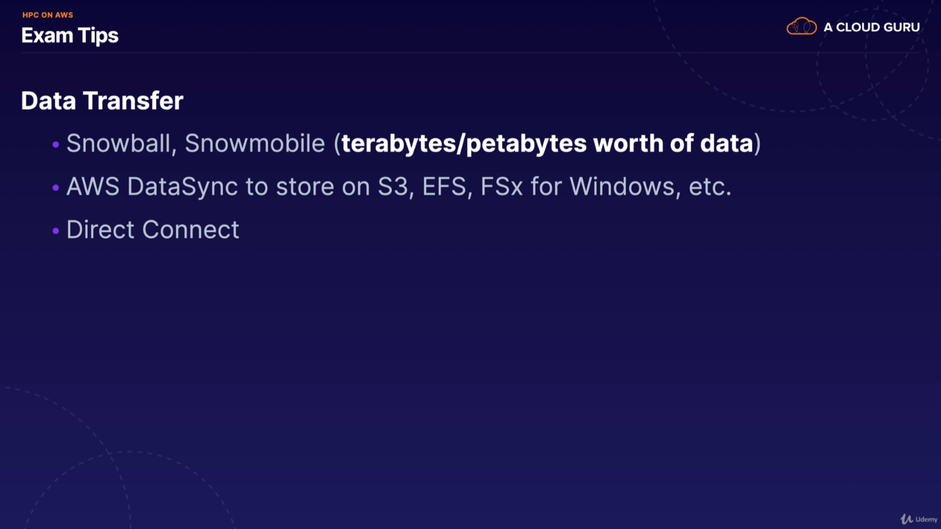

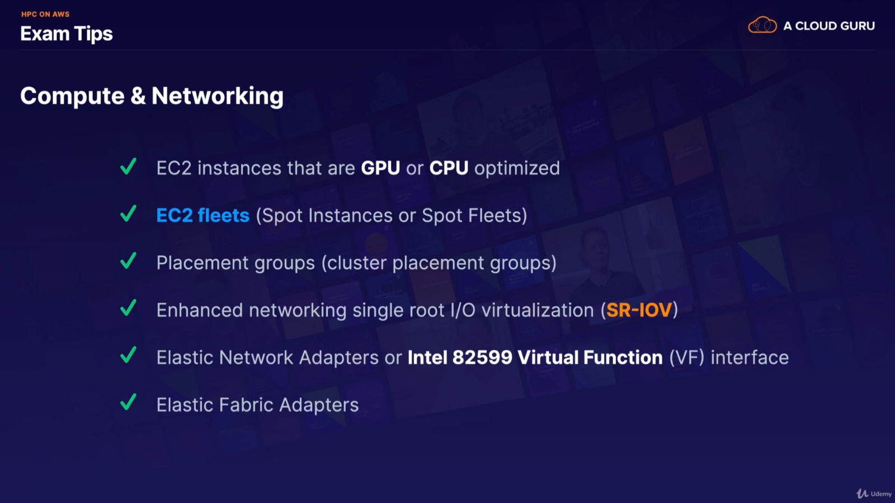

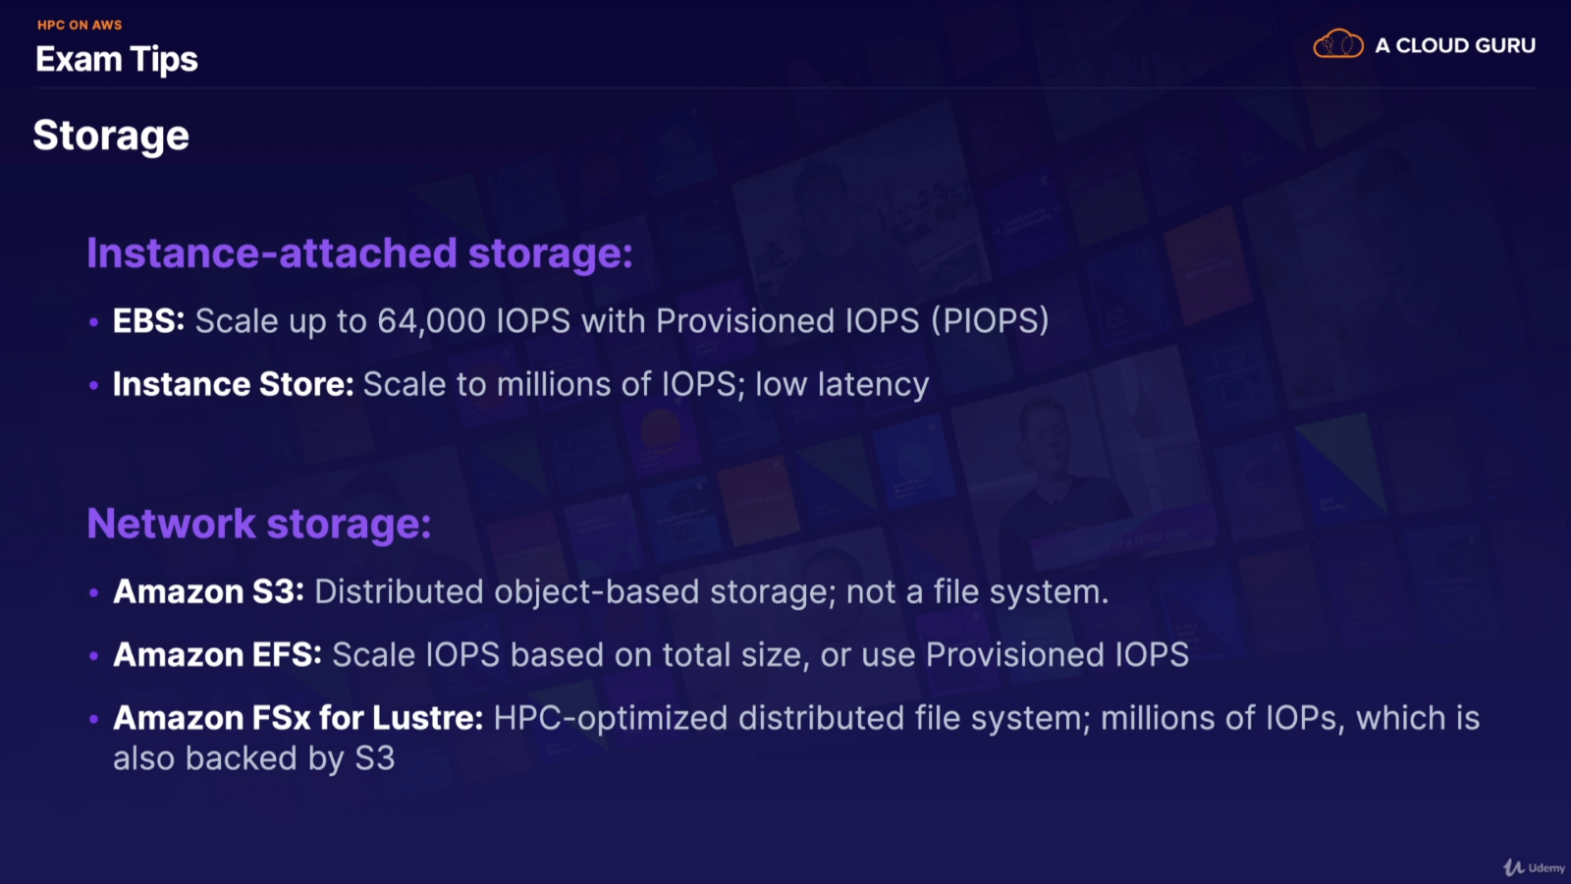

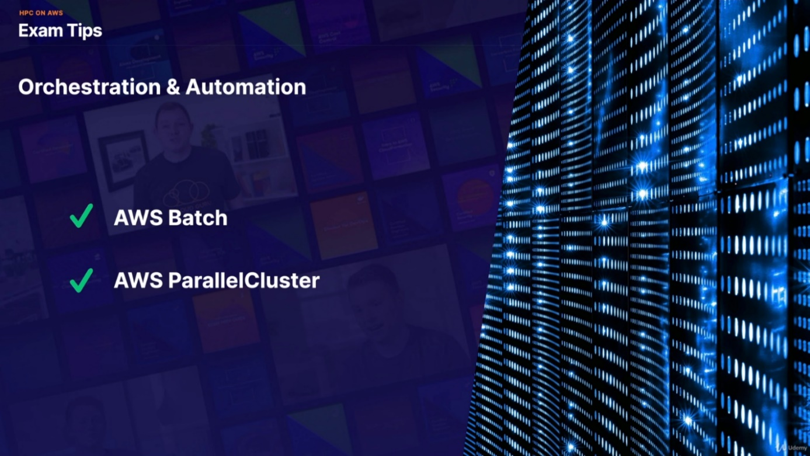

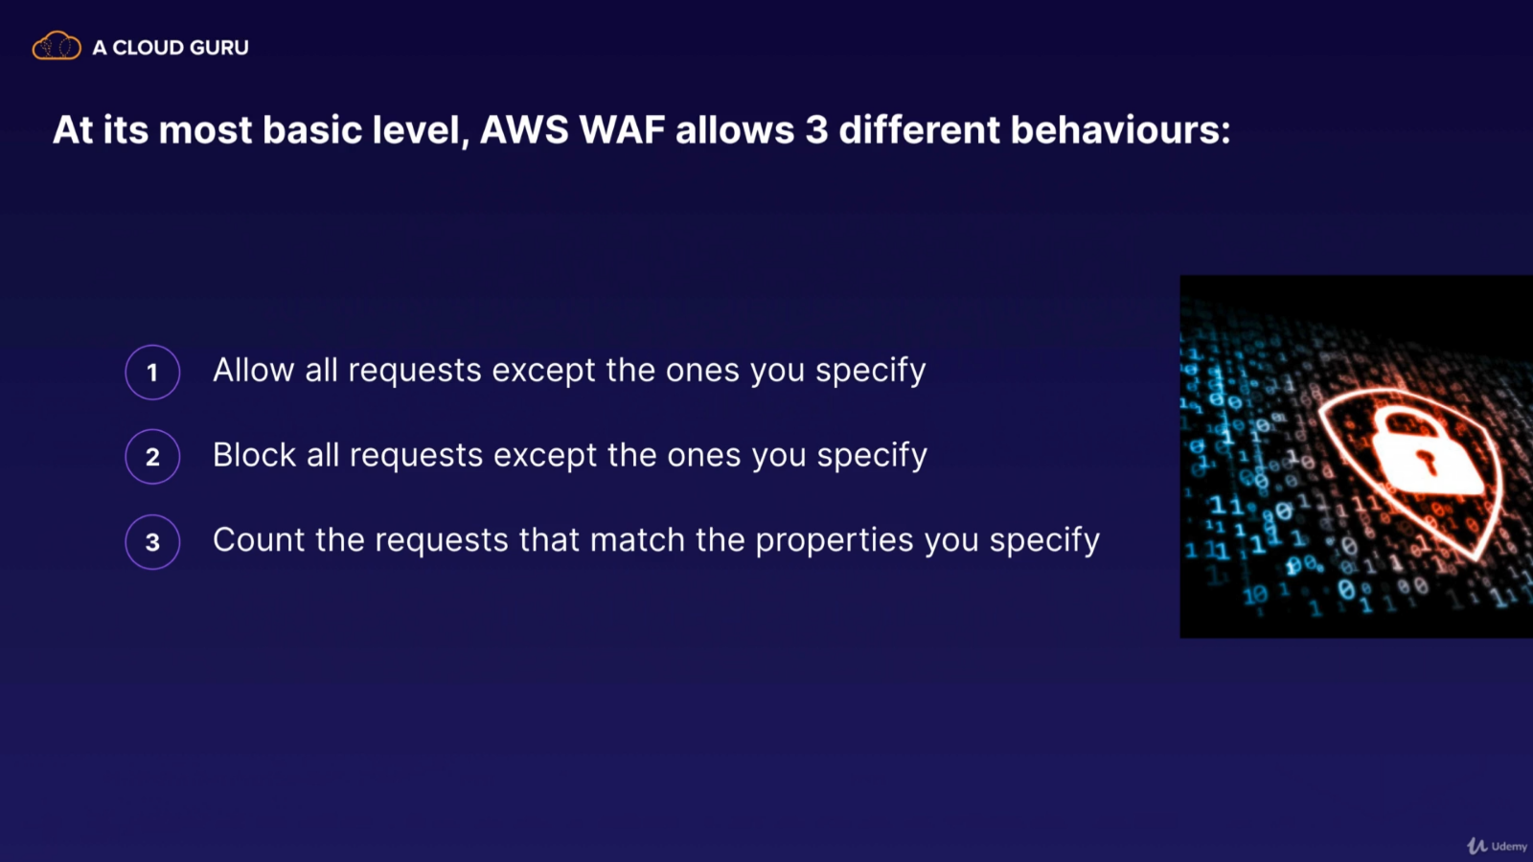

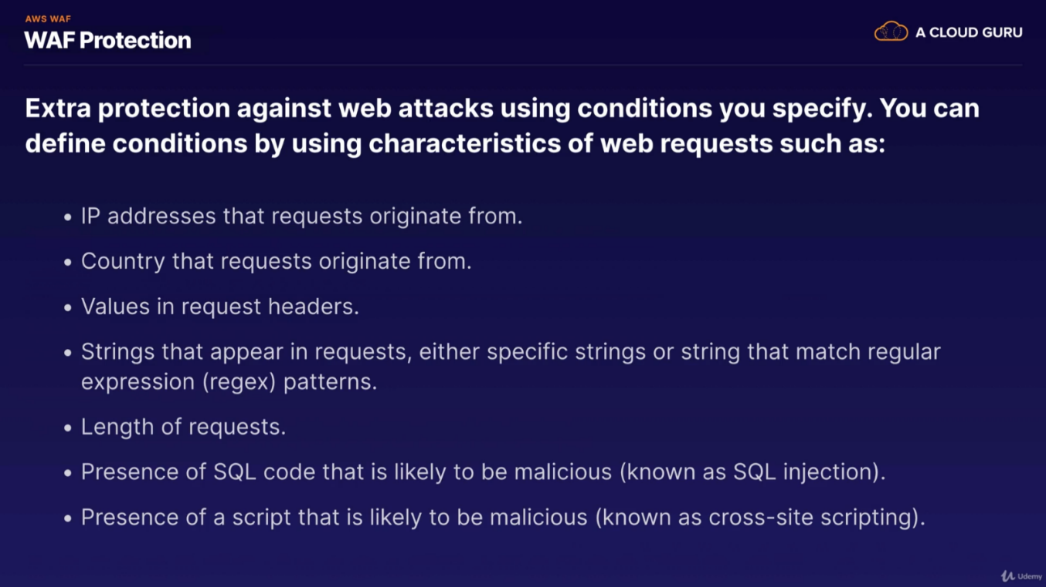

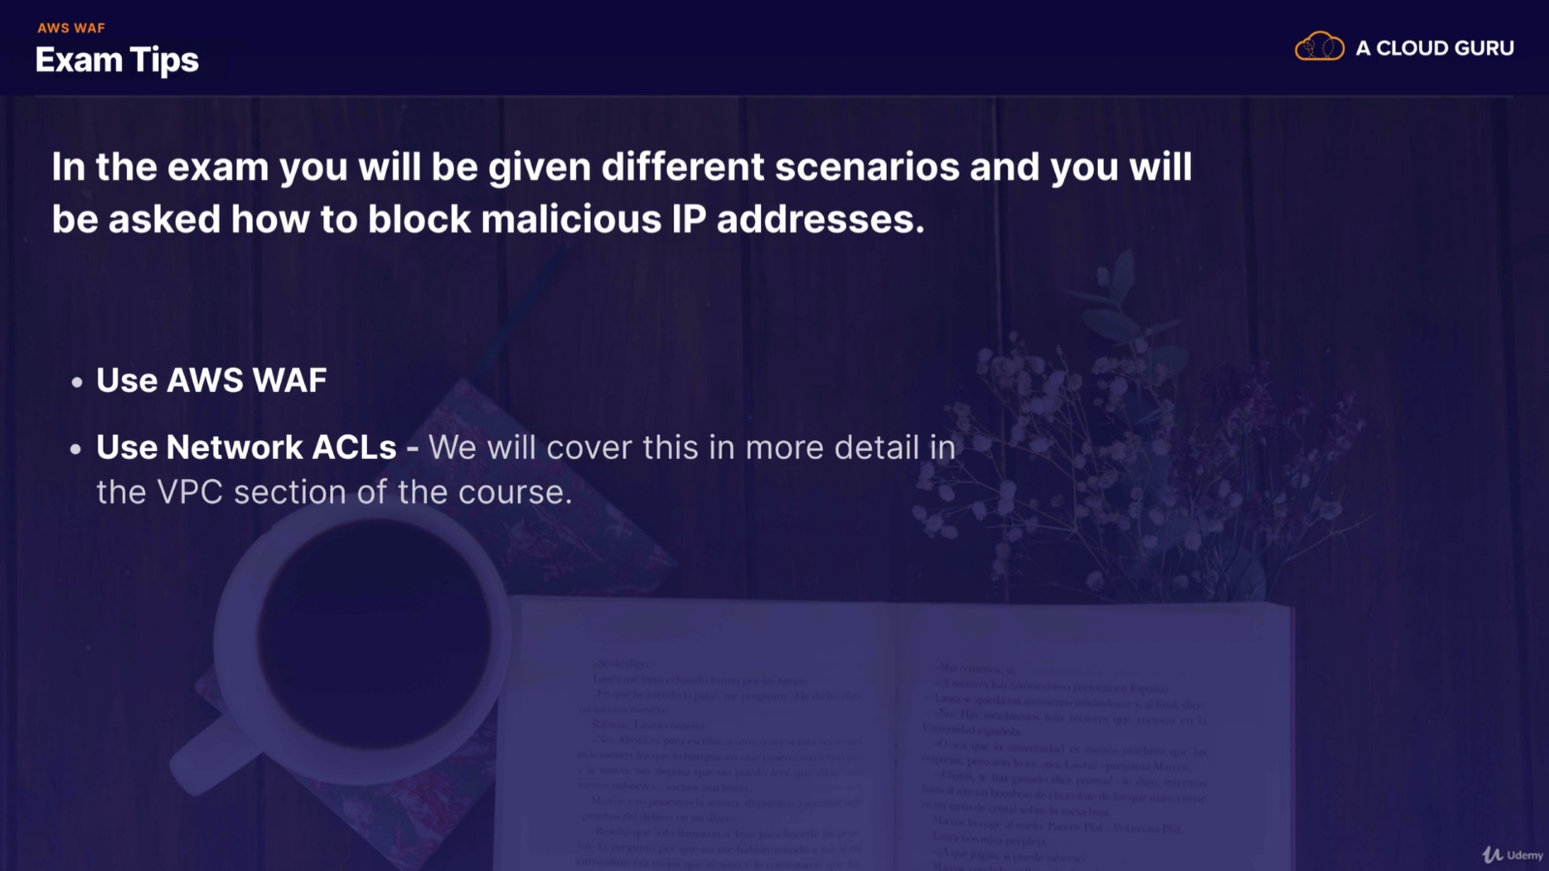

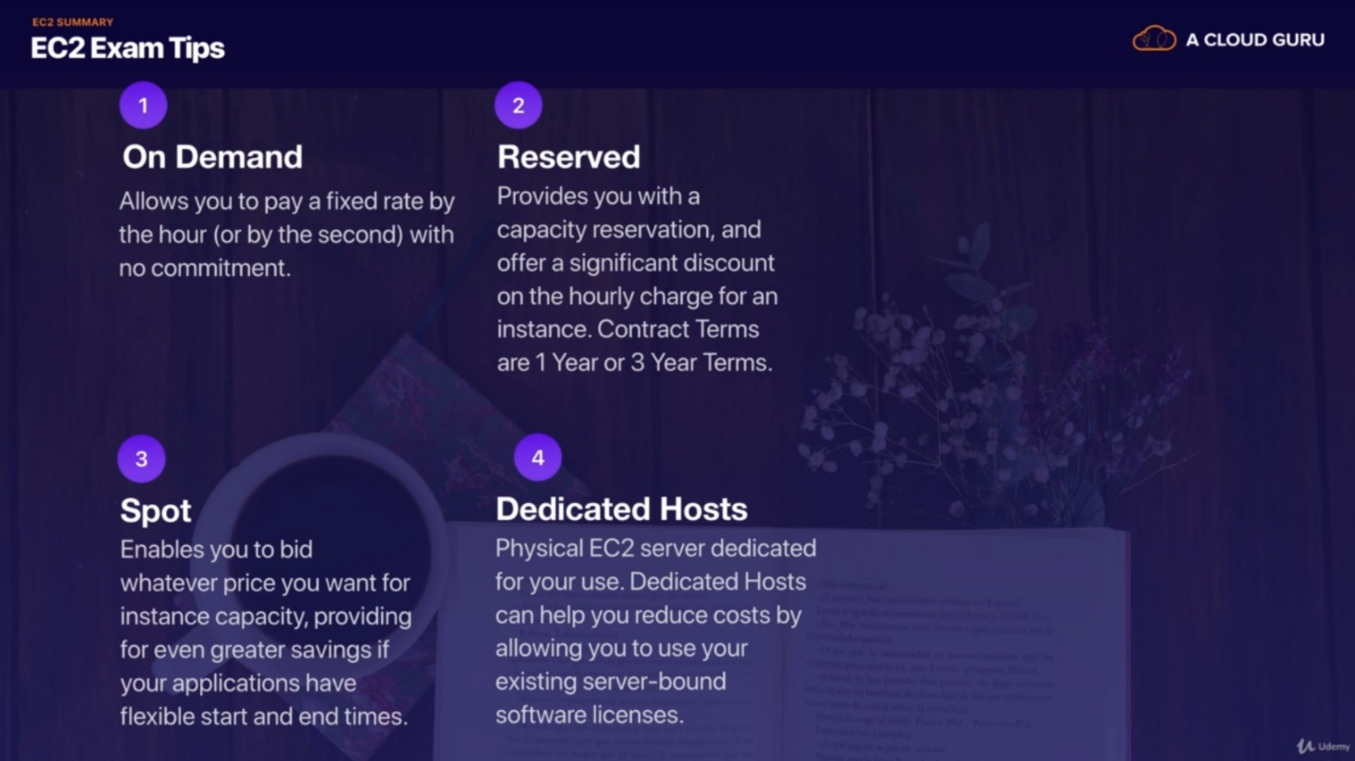

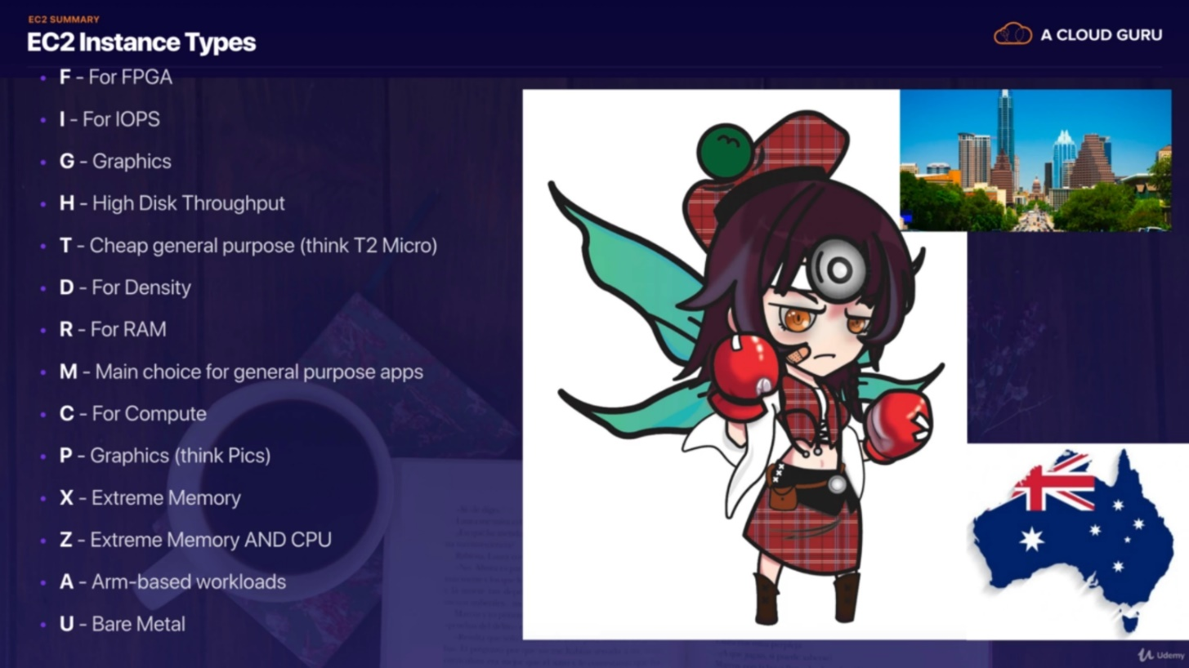

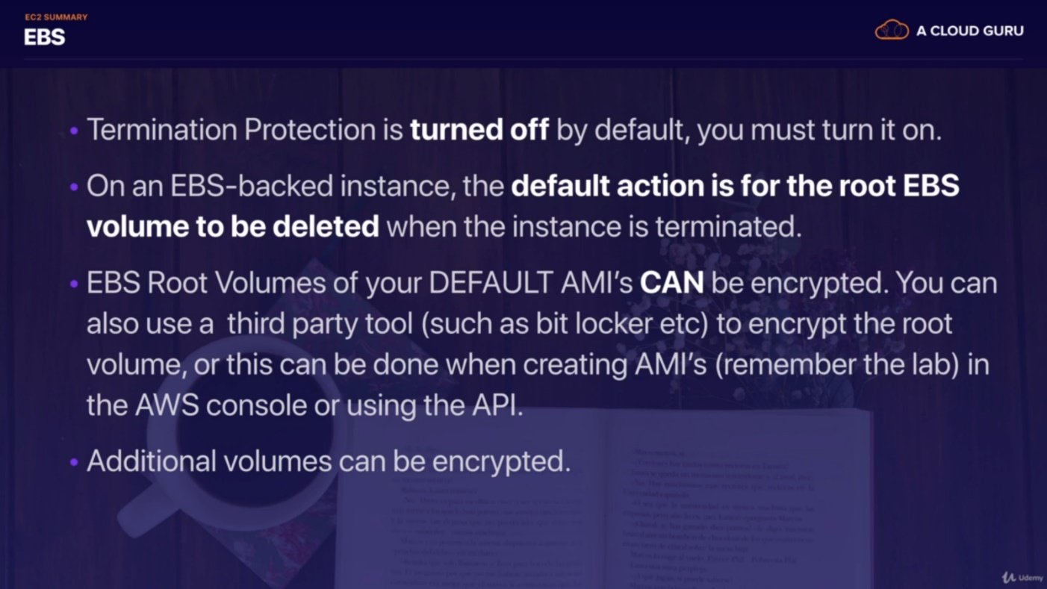

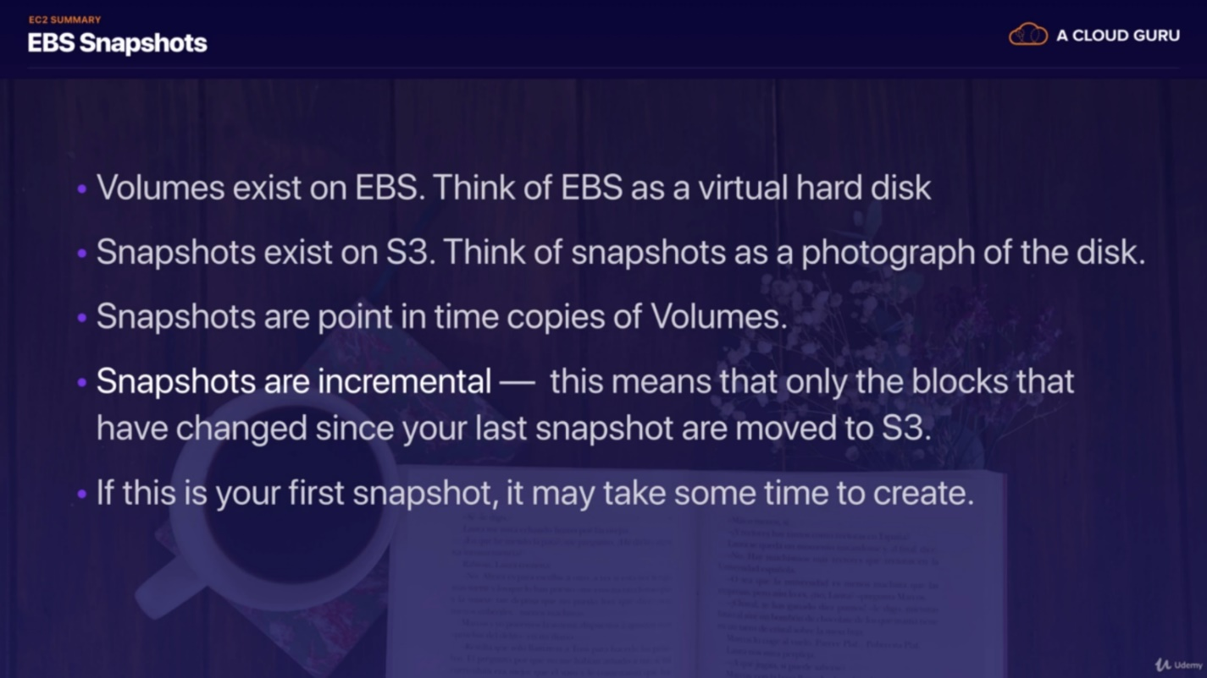

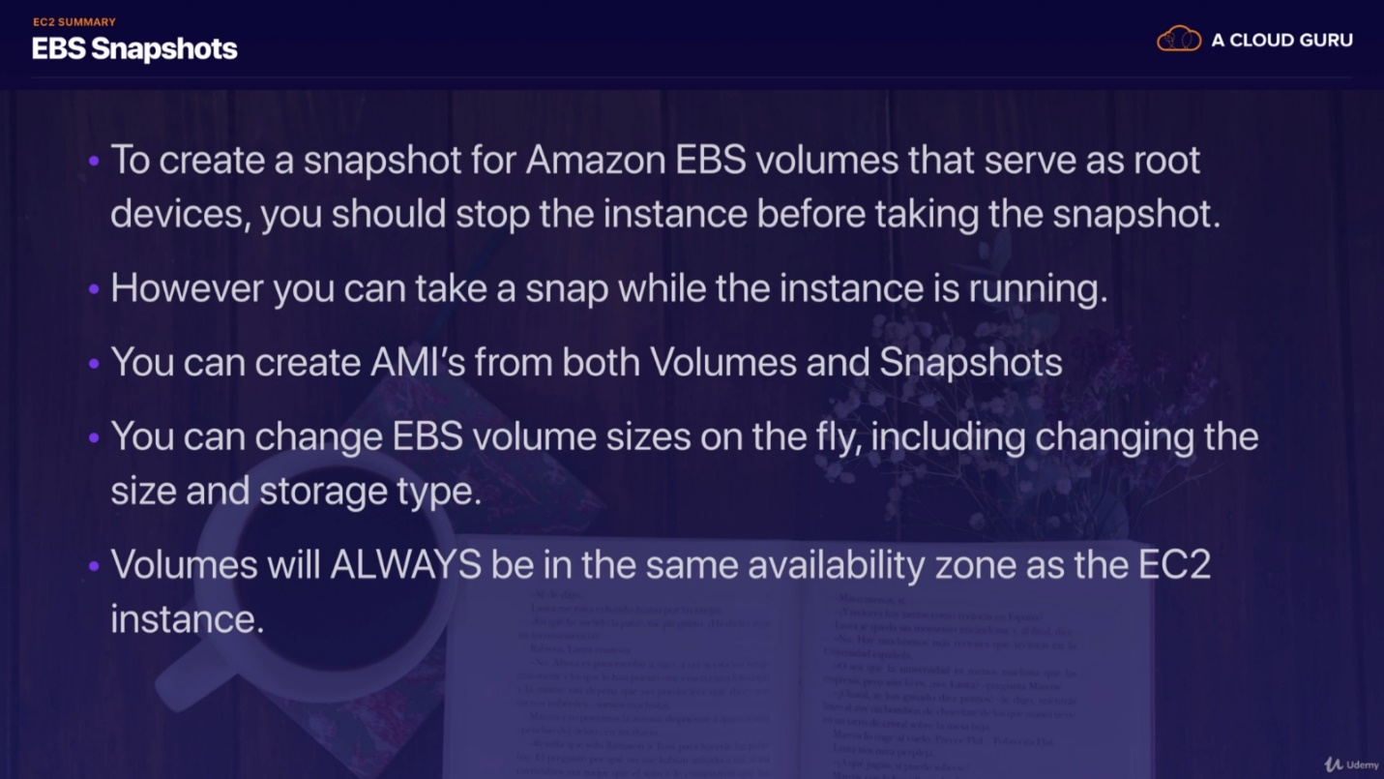

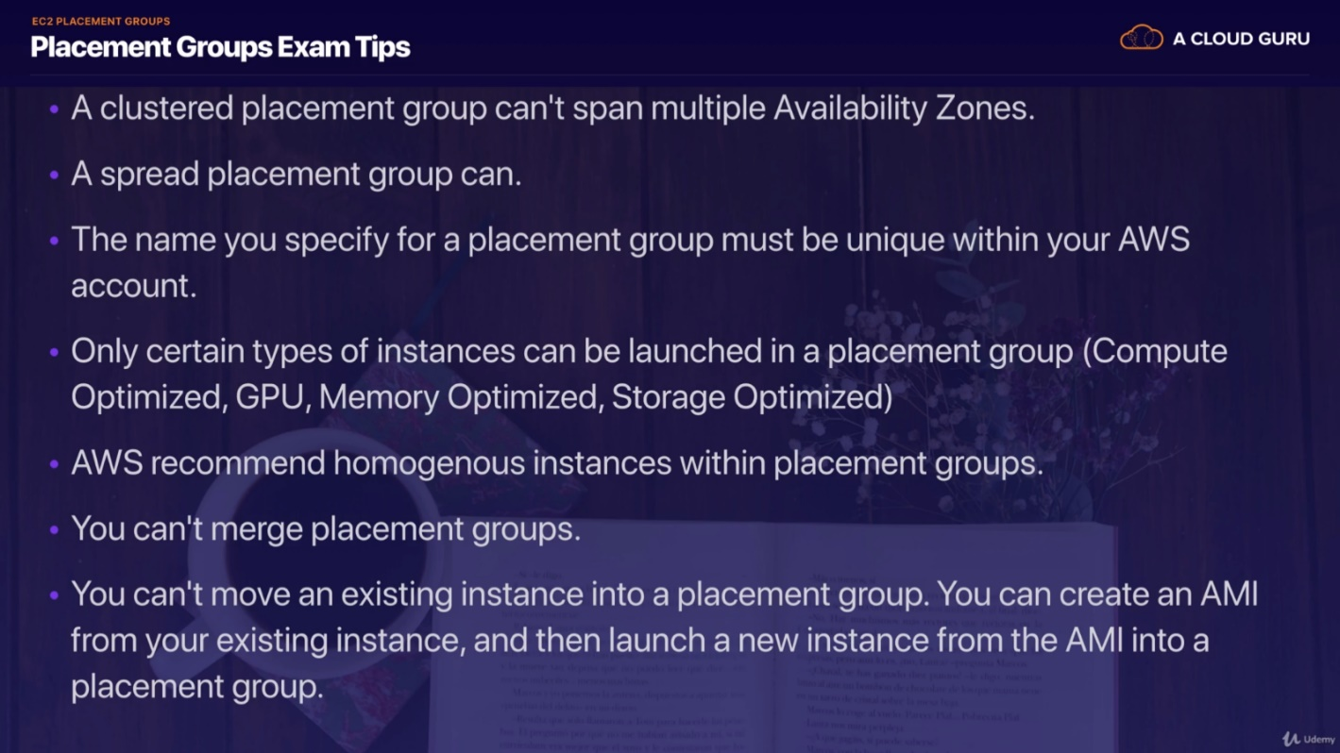

# 5. Databases on AWS

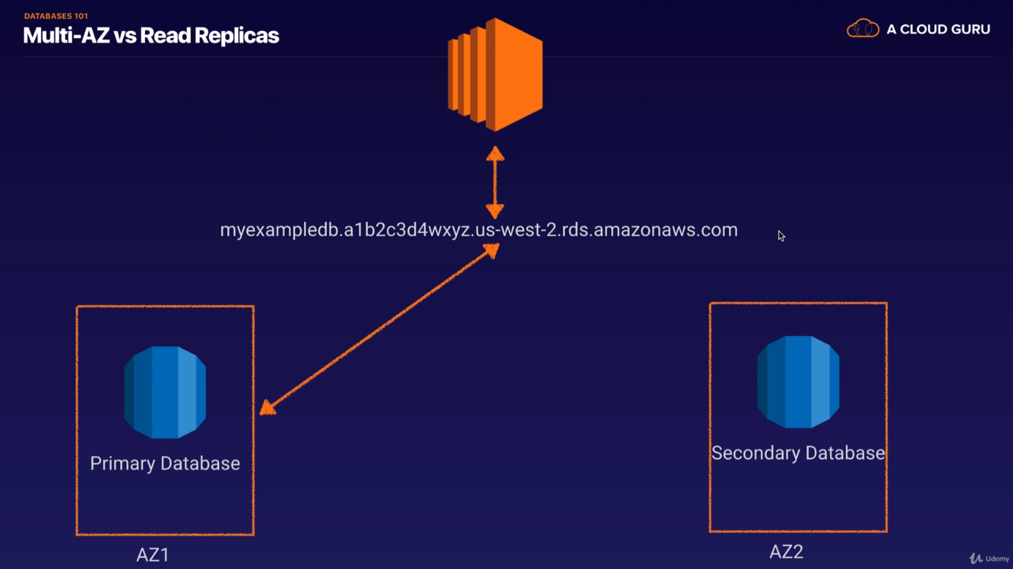

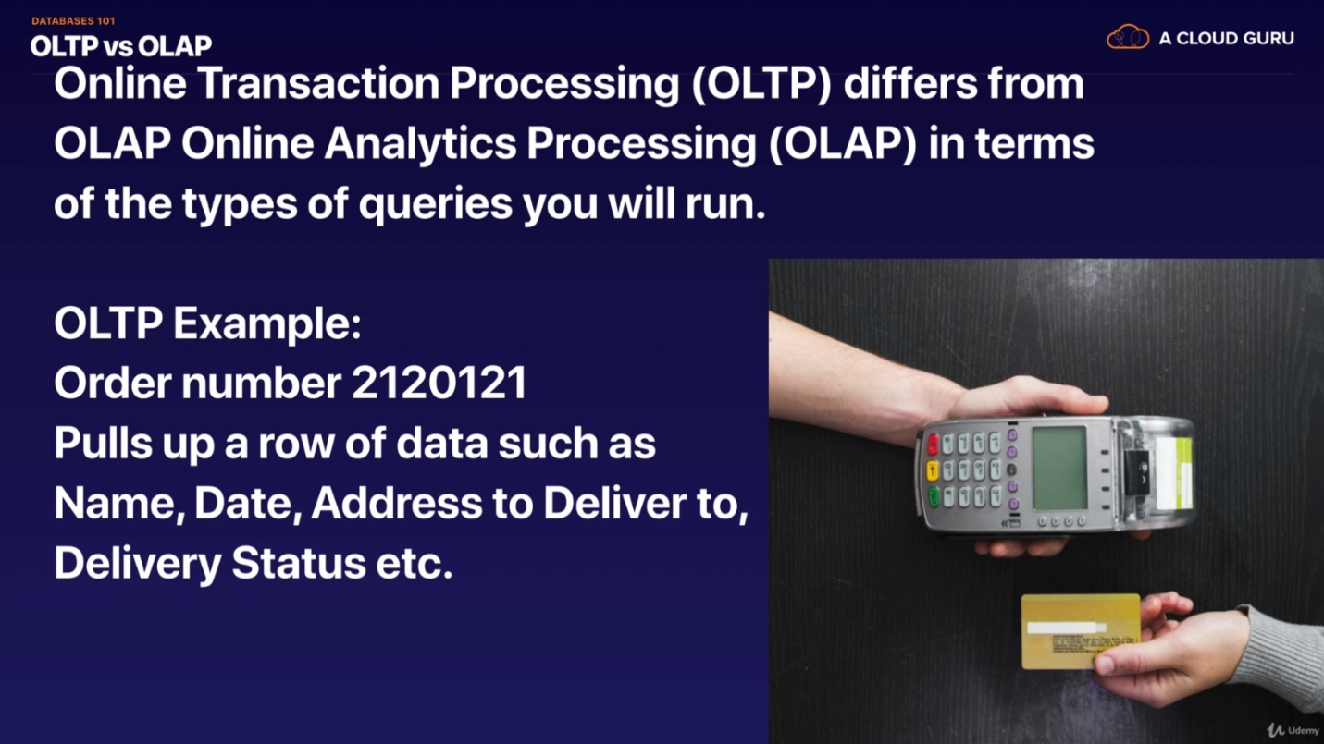

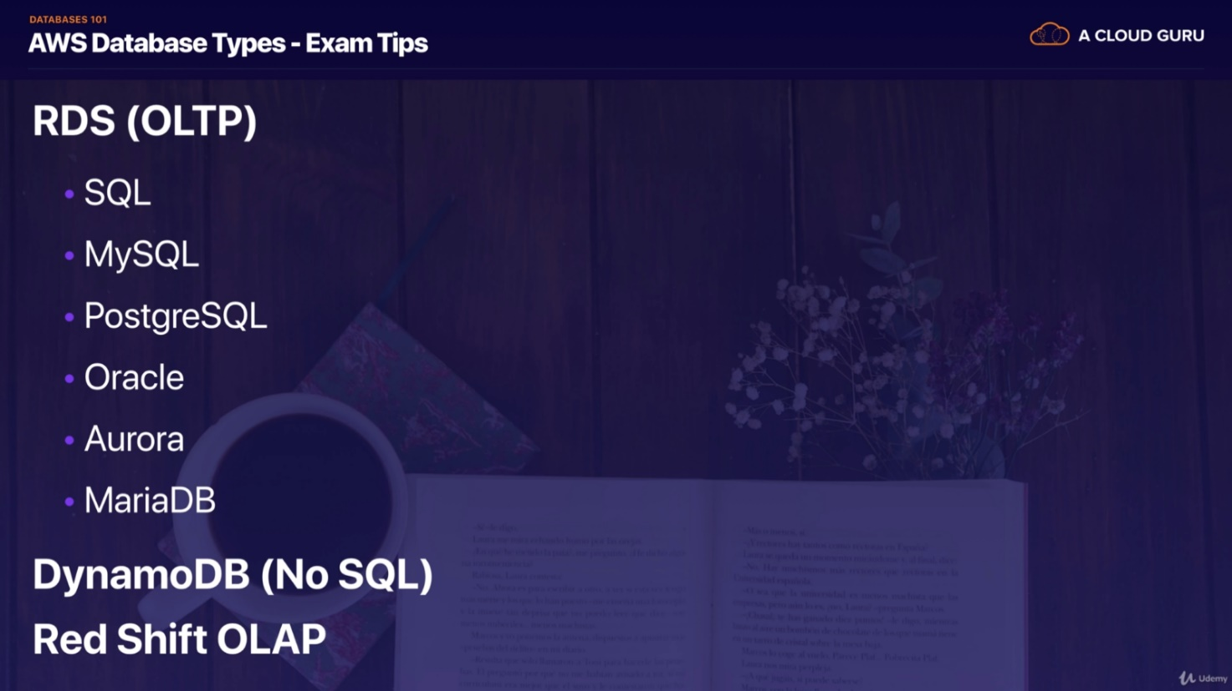

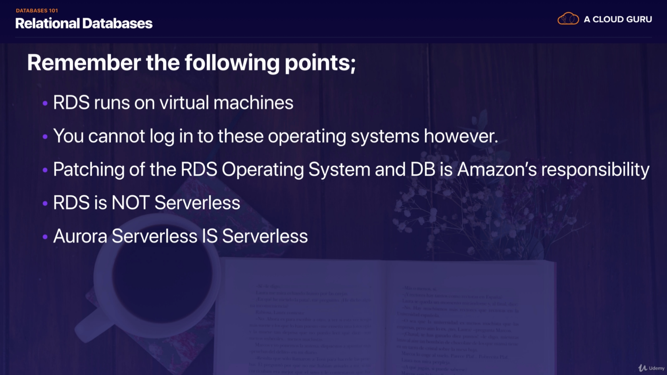

Dynamo DB Advanced:

DAX: a fully managed, high availability, in memory cache. It’s distinct from traditional caches as it **sits in the middle** (and allows write-through) between the client and DynamoDB.

* Reduces request time form millisec to microsec
* Developers don’t need to manage caching logic
* Compatible with existing DynamoDB calls

DynamoDB supports transactions:

* Multiple “all-or-nothing” operations
* Financial transactions
* DynamoDB performs two underlying reads or writes – prepare and commit
* Transactions work with up to 25 items or 4Mb of data

On-demand capacity

* Pay pre request pricing
* Good for prototyping (because it’s more expensive). Want provisioned for steady state levels

On-demand Backup and Restore

* Full backups at any time
* No impact on table performance! – In contrast with Relational Dbs
* Backups are consistent within seconds and retained until deleted
* Operate within same region as source table

Point in time recovery

* Protects against accidental writes/reads
* Restore to any point in last 35 days
* Incremental backups
* Not enabled by default
* Latest restorable timestamp is usually 5 minutes in the past

Streams

* Time ordered sequence of item-level changes in the table
* Stored for 24 hours – inserts, updates, deletes
* Can implement stored procedures (similar to relational dbs) using lambda service

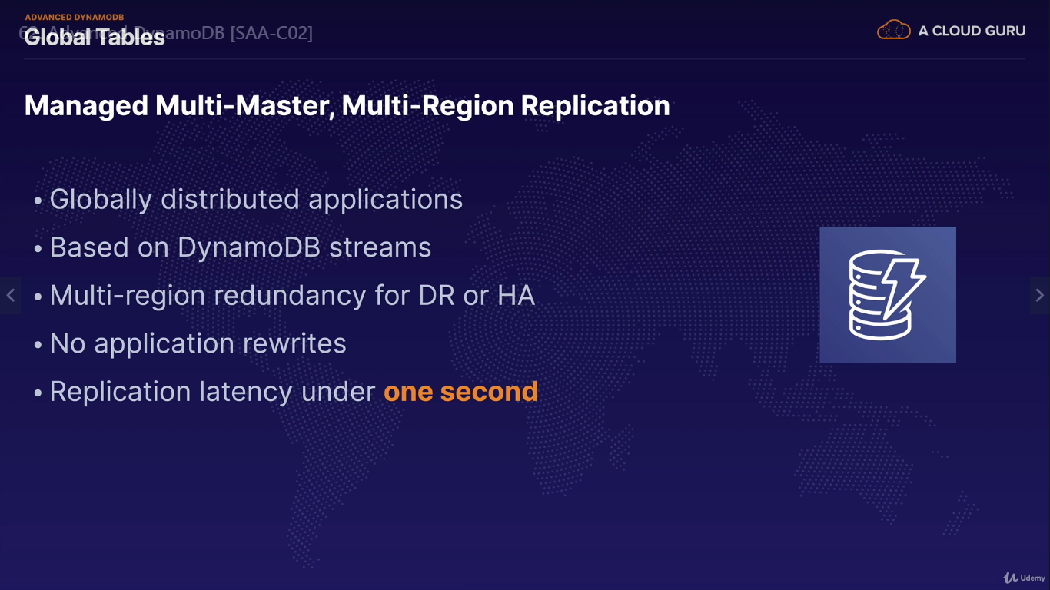

DMS – database migration service

* Migrate database between Sql and no-sql dbs
* All data in dynamoDb is encrypted using KMS
* Site-to-site VPN
* DX
* IAM policies and roles
* Fine grained access – iam policy which allows users access to certain attributes only
* CloudWatch and CloudTrail
* VPC endpoints

**Redshift** is a fast and powerful, fully managed, petabyte scale data warehouse service. Can scale to PB for 1k per TB.

OLTP (looking up orders for a huge store) vs OLAP (running queries against db – net profit for some subset of total sales)

* Data warehouses have diff architecture from traditional DBs

Redshift can be configured as follows:

* Single Node (160Gb)
* Multimode
  + Leader node (manages client connections and receives queries)
  + Compute node (store data and perform queries and computations). Up to 128 compute nodes

Redshift uses advanced compression

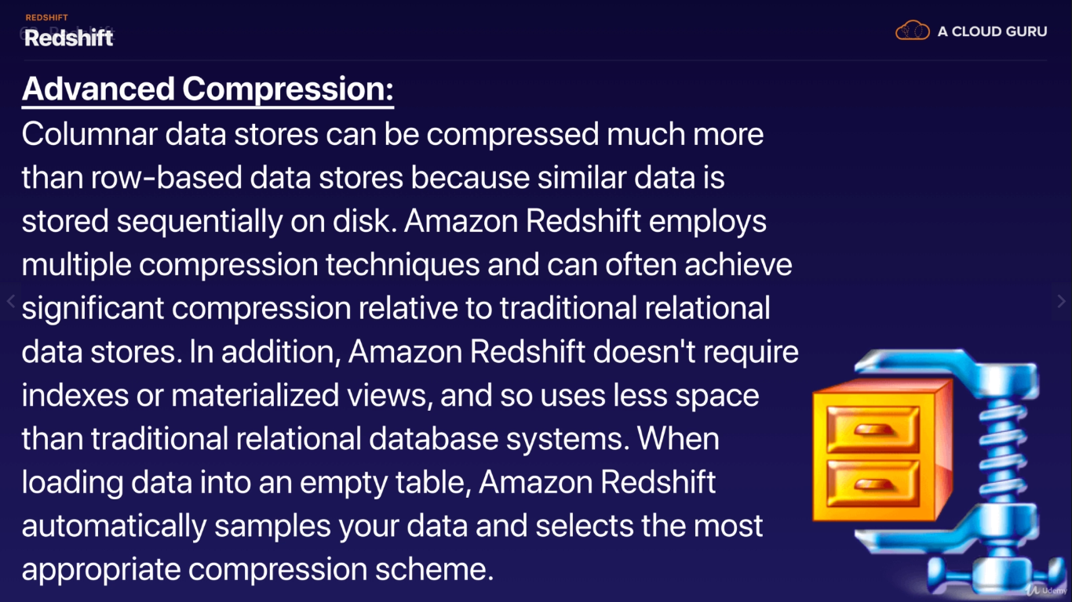

Redshift Massively Parallel Processing (MPP):

* Amazon Redshift automatically distributes data and query load across all nodes
* Redshift makes it easy to add nodes to your data warehouse and enables you to maintain fast query performance as the data warehouse grows.

Backups:

* Enabled by default with 1-day retention
* Max retention period is 35 days
* Redshift always attempts to maintain at least 3 copies of your data (original and replica on compute nodes + one backup in S3)
* Redshift can synchronously replicate snapshots to S3 in another region for disaster recovery.

Redshift is priced based on total Compute Node Hours (total hours across all compute nodes). Leader node is not charged, only compute nodes

Security:

* Encrypted in transit using SSL
* Encrypted at rest using AES 256
* Redshift takes care of key management: HSM (your own) or AWS KMS

You can only have Redshift in 1 AZ. Can restore snapshot to new AZ

EXAM TIPS:

* Redshift is used for BI
* Available in 1 AZ
* Backups:
  + Enabled by default with 1-day retention
  + Maximum retention is 35 days
* Redshift tries to maintain 3 copies of your data (original and replica on compute nodes + one backup in S3)
  + Redshift can asynch replicate your snapshots to S3 in another region for disaster recovery

**Aurora**

* MySQL and PostgreSQL compatible relational DB engine that combines speed and availability of commercial dbs with cost effectiveness of open source DBs
* Starts with 10GB, scales in 10GB increments to 64TB
* Compute resources can scale up to 32vCPUs and 244GB of Memory
* 2 copies of your data is contained in each AZ, with a min of 3 AZs = 6 total copies of your data

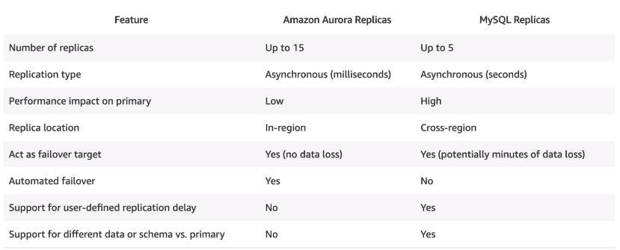

Backups:

* Automated backups are always enabled on Aurora. Backups do not impact db performance
* Snapshots can be taken as well, and they don’t impact performance
* You can share Aurora Snapshots with other AWS accounts

Amazon aurora serverless is an on-demand autoscaling configuration for MySQL-compatible and PostgreSQL compatible editions of Aurora. It is self-managed.

* **Aurora serverless provides relatively simple, cost-effective option for infrequent, intermittent or unpredictable workloads**

**Aurora EXAM TIPS:**

* 2 copies of your data is contained in each AZ, with a min of 3 AZs = 6 total copies of your data
* You can share Aurora Snapshots with other AWS accounts
* 3 types of replicas available. Aurora Replicas, MySQL replicas, and PostgreSQL replicas. Automated failover only with Aurora Replicas
* Aurora has automated backups turned on by default. Can take and share snapshots of Aurora db
* Aurora serverless provides relatively simple, cost-effective option for infrequent, intermittent or unpredictable workloads

**Elasticache**

* Web service that makes it easy to deploy, operate, scale in-memory cache in cloud.
* Used to increase database and web app performance
* To increase web-app performance: add db read replica and use elasticache

**DMS (Database Migration Service)**

* Cloud service to migrate relational db, data warehouse, nosql db and other data stores
* When migrating, you can **create target tables manually** or use **AWS Schema Conversation Tool (SCT)**
* Supports homogenous migrations (same to same db)
* Supports heterogenous migrations (one type of db to another)

**Caching in AWS**

* CloudFront
* API Gateway
* ElastiCache – Memcached and redis
* DynamoDB Accelerator (DAX)

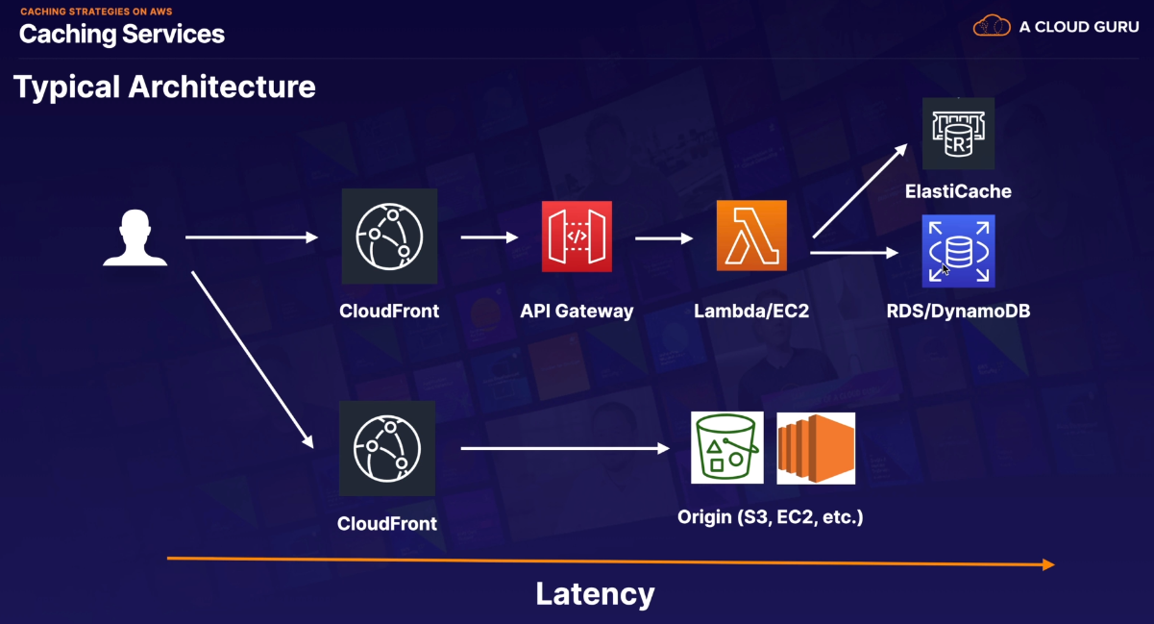

**EMR Overview**

* Cloud big data platform that allows you to run petabyte-scale analysis at less than half the cost of traditional on-prem solutions. Over 3 times than Spark
* Central component of EMR is the cluster. A cluster is collection of Amazon Elastic Compute Cloud (Amazon EC2) instances where each instance in the cluster is a node.
  + EMR installs different software on each node, giving it a particular role in the distributed application – called *node type*.
    - Master node – tracks status of tasks and monitors health of cluster
    - Core node – run tasks and store data in HDFS. In the cluster, there is at least one core node
    - Task node – only runs tasks and does not store data in HDFS. Task nodes are optional.
* All log data in EMR is stored on the master node – you can set periodic backups to go into S3 so that data is not lost if master node crashes.
  + You can only set this up when first creating EMR cluster. Log files are archived to S3 at **five-minute intervals**

**Databases Summary**

* RDS
  + SQL
  + MySQL
  + PostgreSQL
  + Oracle
  + Aurora
  + MariaDB
  + RDS runs on VMS (that you cannot SSH into). Patching is handled by AWS
  + RDS is not Serverless except Aurora Serverless
  + Two types of backups for RDS:
    - Automated Backups
    - DB Snapshots
  + Read Replicas
    - Can be Multi-AZ
    - Can be used to increase performance
    - Must have backups turned on
    - Can be in different regions
    - Can be MySQL, PostgreSQL, MariaDB, Oracle, Aurora
    - A read replica can be promoted to master, this will break the Read Replica
  + Multi AZ
    - Used for Data Replication
    - Can force a fail a failover from one AZ to another by rebooting the RDS instance
  + Encryption is supported for all RDS DBs listed above. All backups, read replicas and snapshots are encrypted as well for that DB instance.
* NoSQL
  + DynamoDB
    - Stored on SSD
    - Spread across 3 Regions
    - Eventual Consistent Reads -- DEFAULT OPTION
    - Strong Consistent Reads
* Redshift OLAP
  + Enabled by default with 1 day retention
  + Max retention is 35 days
  + Redshift attempts to maintain at least 3 copies of your data (original and replica in compute nodes and backup in S3)
  + Redshifts can asynch replicate snapshots to s3 in another region
* Aurora
  + 2 copies of your data are in AZ with min of 3 AZ
  + Can share Aurora snap shots with other AWS accts
  + 3 types of replicas available: Aurora, MySQL, PostgreSQL. Auto failover only with Aurora replicas
  + Aurora has automated backups on by default. You can also take and share snapshots of the db
  + Use Aurora serverless for simple, cost-effective option for unpredictable workloads
* ElastiCache: Used for increasing database and web application performance
  + Memcached
    - Use if you need horizontal scaling
  + Redis
    - Is multi-AZ
    - Can do back ups and restores of Redis

# 6. Advanced IAM

**Directory Services:**

* Family of managed services
* Connect AWS resources with on-prem AD
* Standalone directory in the cloud
* Use existing corporate creds
* SSO to any domain joined EC2

Active Directory:

* High availability, On-prem directory service
* Hierarchical db of users, groups and computers – trees and forests
* Group policies
* LDAP and DNS
* Kerberos, LDAP and NTLM auth

AWS managed MS AD

* AD Domain Controllers running on Win Servers
* You can extend AWS AD to on-prem using *AD Trust*

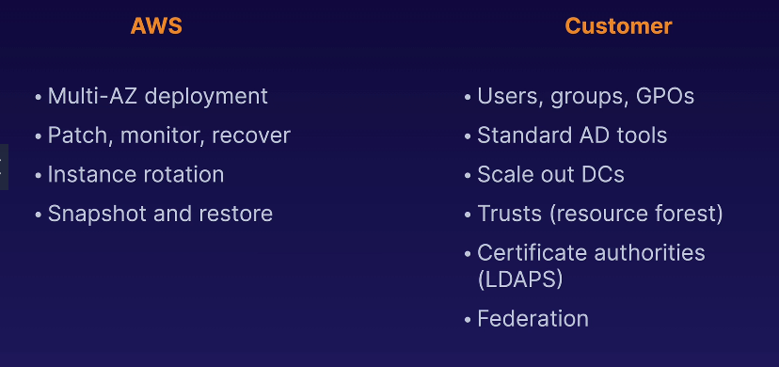

Simple AD

* Standalone managed directory
* Basic AD Features
* Small < 500 users and large < 5000 users
* Easier to manage EC2
* Linux workloads that need LDAP
* **Does not support trusts** (can’t join on-prem AD)

AD Connector

* Directory gateway (proxy) for on-prem AD
* Avoid caching info in cloud
* Allow on-prem users to log into AWS’
* Join EC2 instances to existing AD domain
* Scale across multiple AD Connectors (horizontally)

Cloud directory

* Directory-based store for developers
* Multiple hierarchies with hundreds of users
* Use cases: Org charts, course catalogs, device registries
* Fully managed serveice

Amazon Cognito User Pools

* Managed user directory for SaaS applications
* Sign up and sign in for web or mobile directors
* Works with social media identities

**EXAM TIPS**

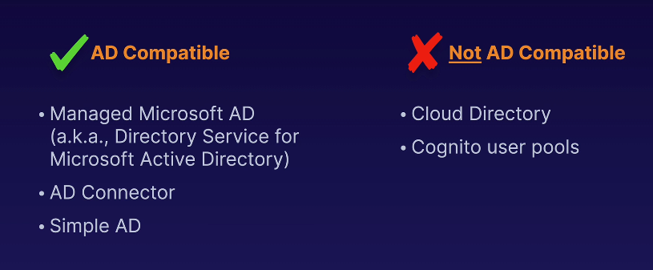

**IAM Policies:**

ARNs (amazon resource name) begin with: arn:partition:service:region:account_id:resource_type/resource(:/qualifier)

* Policy is a JSON document that defines permissions
  + Identity policy (user permissions)
  + Resource policy (who has access to resource)
  + Policy has no effect until attached
  + Policy is a list of statements in json format

Video 71: IAM policies

**IAM policies:**

* Implicit deny (by default)
* Explicit deny → override everything else in anything
* Only attached policies have an effect
* AWS joins all applicable policies attached to a resource (union)
* AWS managed vs customer managed policies

Permission boundaries:

* Used to delegate administration to other users
  + Ie. Developers creating roles for a specific service
* Permission boundaries are supported for IAM entities: users or roles
  + These are used to prevent privilege escalation or broad permission
  + IAM entity can perform only the actions allows by identity-based policy and permission boundaries
  + Control maximum permission that IAM policy can grant. Acts as a constraint on the User or role based policy (hence boundary)

**AWS Resource Access Mgr (RAM)**

* Allows controlling of creating and sharing resources across accounts
* The account a resource is being shared with has to accept the share request

**AWS SSO**

* Centrally managed access to AWS accounts and other applications
* If SAML 2.0 is mentioned in the exam, look for SSO in answers

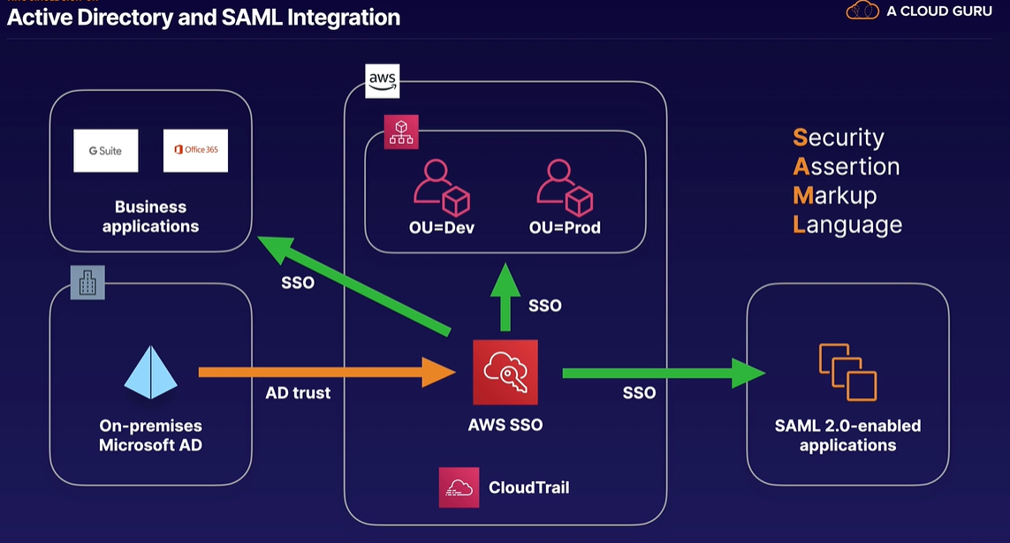

**Advanced IAM Summary:**

**Directory service:**

* AD
* Directory service allows to connect AWS resources with on-prem AD
* SSO to any domain joined ec2 instance
* AWS managed MS AD
* AD trust
* AWS vs. customer responsibility

Simple AD (does not support trusts).

Need AD connector to connect on-prem AD to AWS AD

Cloud Directory

Cognito user pools

AD vs. non-AD compatible services

IAM policies:

* ARN syntax
* IAM policy structure – json
  + Effect / action / resource
* Identity vs resource policies
* Policy evaluation logic
* AWS vs customer managed policies
* Permission boundaries.

Resource Access Manager (RAM)

* Resource sharing between accounts
* Individual accounts and AWS orgs
* Types of resources that can be shared

SSO

* Centrally managed access, across aws + multiple business applications
* Use existing identities
* Account level permissions
* SAML (sec assertion markup language)

# 7. Route 53

1st video Exam tips:

- ELBs do not have a pre-defined ipv4 address. You resolve to them using DNS name

- Understand difference between Alias record and CNAME (CNAME can’t be used for naked domain name)

- Common DNS types:

- SOA Records

- NS Records

- A Records (ipv4)

- CNAMES

- MX (mail exchange) Records

-PTR Records

- TXT Record

- PTR Record

- AAAA (ipv6)

You can buy a domain name directly with AWS. Takes up to 3 days to register

Routing policies with Route53:

- Simple Routing

- Weighted Routing

- Latency-based Routing

- Failover Routing

- Geolocation Routing

- Geoproximity Routing (Traffic Flow only)

- Multivalue Answer Routing

**Simple Routing**

One record mapping to multiple addresses. When multiple DNS addresses are defined, R53 returns all values to user in random order

**Weighted Routing**

- Attach weights to IPs that a DNS name resolves to.

- Can add health checks in addition to weights. Unhealthy instances/IPs are removed from the total pool

- Can set up SMS notifications

**Latency Routing policy**

- Based on nearest geographic location

**Failover Routing**

- When the active instance fails, the backups instance is routed to as a replacement

**Geolocation**

- Based strictly on location nearness of user to a resource

**Geoproximity**

- Allows Route 53 to route traffic to your resources based on geographic location of your users and your resources. You can optionally add bias with expands or shrinks the size of geographic region from which traffic is routed to a resource.

- To use geo-proximiity routing, you must use Route 53 traffic flow

**Multivalue Answers**

- Return multiple values for DNS queries. Multivalue lets you check health of each resource so Route 53 only returns values for health resources

- Similar to simple routing with health checks on each record

**Section Summary**

- ELBs don’t have pre-defined ipv4 addresses, need to resolve them using DNS name

- Diff b/w ALIAS (Name and A records) and CNAME (Reference to another record)

- Always choose Alias name over CNAME

- Routing policies and record types above

- Health checks

# 8. VPCs

**NAT:**

* Allow instances in private subnets to access internet
* NAT Gateway (managed service) vs NAT instances (depreciating)
* In the subnet router, you configure it to route external (out to internet) traffic via the router
* On a NAT instance, you need to disable source and destination checks (it’s acting as a gateway) on IP packets
* NAT instance must be in a public subnet
* There must be a route out of private subnet to NAT instance (for IGW to be accessible)
* The amount of traffic supported by a NAT instance depends on the instance size
  + You can create high availability using Autoscaling Groups, multiple subnets in different AZs and script automatic failover
* NAT instances are behind a security group
* NAT gateways:
  + Redundant inside AZ
  + Preferred
  + Starts at 5Gbps and scales to 45Gbps
  + Not associated to SG
  + If you have instances in multiple AZ and a NAT Gateway in **one** AZ. If the AZ with NAT GW goes down, all other instances are going to lose internet access.

**NACL:**

* In a new NACL, default is to deny everything
* A subnet can only be associated with one NACL. Whereas NACL can be associated with many subnets
* NAT GW uses range of 1024-65535 which is added to outbound rules of NACL. These are for ephemeral ports of server ephemeral ports (basically the port that a request to server is served on after initial request to generic port – the connection switches to this port to keep generic port available for new requests)
* If you have a deny, generally you want to add it before allow. Rules are looked up in a top down fashion
* Generally you use NACLs to **block** incoming IP addresses
* NACLs are stateless. Responses are subject to outbound rules. They’re a simple filter that doesn’t track state.

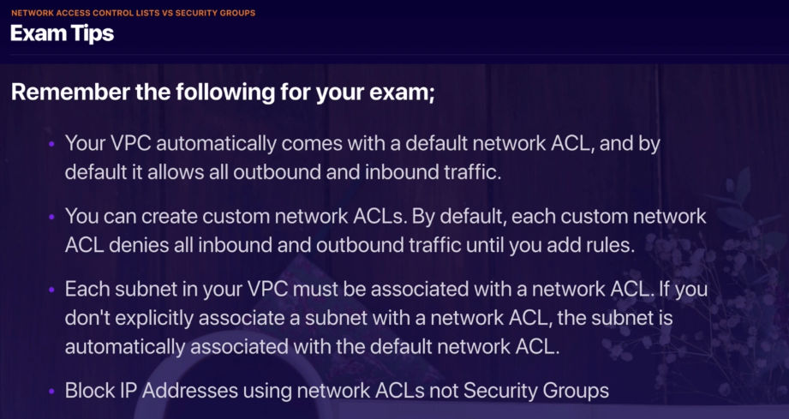

**Custom VPCs and ELBs**

* When provisioning a load balancer, you need at least 2 public subnets

**VPC Flow Logs**

* This is a feature that enables you to capture information about the IP traffic going to and from network interfaces in your VPC. Flow log data is stored using AWS CloudWatch Logs
* Flow logs can be created at 3 levels:
  + VPC
  + Subnet
  + NIC
* Cannot enable flow logs for peered VPCs owned by other accounts
* You can tag flow logs
* After creating a flow log, you cannot associate a different IAM role with the flow log
* Not all IP traffic is monitored:
  + Traffic generated by instances when they contact Amazon DNS
* Traffic for instance meta data or Windows activation
* DHCP traffic and reserved VPC ip addresses is not monitored.

**Bastion:** Single instance that can be hardened to reduce attack surface

Know below – comes up in test

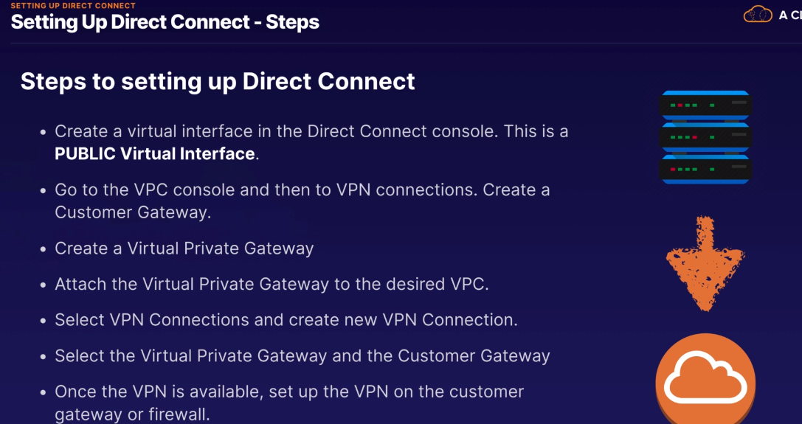

* Before you can create a public VIF, you have to have a DX entry under the DX service
* A VPN connection takes in the options of VGW (Virtual Private Gateway) and Customer Gateway

# 9. HA Architecture

**Autoscaling**

* 107. Autoscaling groups lab
* Auto scaling group is what It souds like. You define number of instances, upper, lower limits and the metric to launch additional instances on (CPU, network in/out)
* 108. HA Architecture
* Plan for failure

**Summary:**

* 3 types of load balancers
  + Application Load balancers (Layer 7 aware)
  + Network Load Balancers (extreme performance where you need a static IP address)
  + Classic Load Balancers (low cost)
* 504 error means gateway timeout. Means application is not responding within idle timeout.
  + Troubleshoot application. Is the webserver not responding or database server?
* Instances monitored by ELB are reported as: inService or OutofService
  + Health Checks check instance of health by talking to it
  + Load balancers always have a DNS name
  + Read ELB FAQ for classic load balancers
* Sticky sessions
  + Enable your users to stick to same EC2 instance for a session (disable if you want to distribute incoming connections)
  + Cross Zone load balancing – enables you to load balance across multiple AZs
  + Path patterns allow you to direct traffic to different EC2 instances based on the URL contained in the request
* CloudFormation : Script your cloud environment
  + Quick Start is a set of CF templates already built by AWS
* Elastic Beanstalk – deploy and manage applications in AWS Cloud without worrying about infrastructure
* Highly available bastion hosts: 2 instances in 2 public subnets in diff AZs. Use a network load balancer with static IP address to route traffic to both. In the case one goes down, all traffic goes to other instance

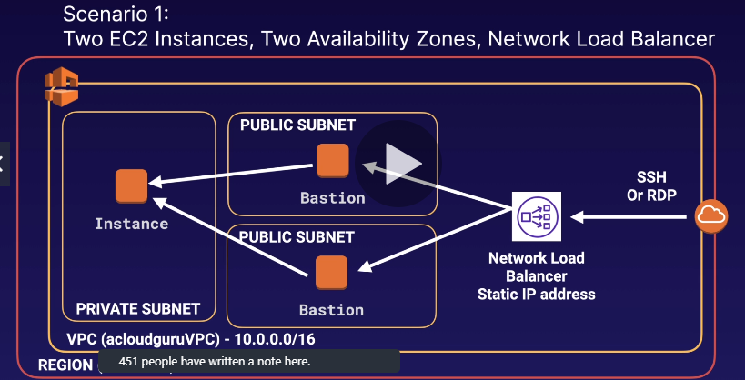

* + In the above scenario, you use a *network load balancer* because Layer 4 routing is required
  + As an alternative, you can also run one host behind an auto scaling group which will respawn the instance when it goes down. The downside is that it will not be 100% available (between failover and recovery)
* High level services you can use on-prem
  + Database Migration Service (DMS)
  + Service Migration Service (SMS)
  + AWAS Application Discovery Service
  + VM Import/Export Service
  + Download Amazon Linus 2 as ISO

# 10. Applications

* SQS: Simple queue service
  + Runs in 2 modes:
    - FIFO
    - B
  + Decrease interval time if you’re getting duplicates in the processor applications. This happens because a message is not processed and acknowledged in time, so it is re-added to the queue.
* SWF ([Amazon] Simple Workflow:
* SNS: Simple notification service
  + Can do push notifications from cloud to mobile devices
  + Can also do sms, or email to SQS queues or any HTTP endpoint
  + Group multiple recipients using topics
* SNS (push) vs. SQS (pull/poll)
* Elastic Transcoder: Media transcoder in cloud
  + Transcode so files play on various devices
  + Provides transcoding presets based on device
* API Gateway: A fully managed service that makes it easy for developers to publish, maintain, monitor and secure APIs at any scale
  + Can talk to backend resources which reside on EC2, Lambda, DynamoDB.
  + API Gateway can: Expose HTTPS endpoints to define a RESTful API
  + Serverlessly connect to services like lambda and DynamoDB
  + Send each API endpoint to different target
  + Track and control usage by API key
  + Throttle requests to prevent attacks
  + Connect to CloudWatch to log all requests for monitoring
  + Maintain multiple versions of your API
  + Configuring API gateway:
    - Define an API (container)
    - Define resources and nested resources (URL Paths)
    - For each Resource:
      * Select supported HTTP methods (verbs) – GET/POST etc
      * Set security
      * Choose target (EC2, Lambda, DynamoDB)
      * Set request and response transformations
  + Deploy API Gateway:
    - Uses API Gateway domain by default (can make it custom)
    - Now supports AWS Certificate Manager (free SSL/TLS certs)
  + API GW supports caching to increase performance
  + API GW is low cost and scales automatically
  + API GW can be throttled to prevent attacks
  + Enable CORS if using JS/AJAX that uses multiple domains with API GW
    - CORS is enforced by the client (your browser)
* Kinesis
  + Streams have shards
  + Firehose – no persistent storage and data has to be analyzed as you go (using lambda for eg)
  + Analytics does what it sounds like
* Web identity federation & Cognito
  + Web ID federation lets you give users access to AWS resources after they’ve auth’d via FB/AMZN/GOOG. The auth code from web id provider (after signing on with another service) serves as temp AWS creds
  + Amazon Cognito provides Web Id Federation with the following features:
    - Sign-up and sign-in to your apps
    - Access for guest users
    - Acts as identity broker between your application and Web ID providers (no additional code required)
    - Sync user data for multiple devices
    - Recommended for all mobile AWS services
    - Uses a SSO provider to grant temp AWS credentials which map to an IAM role allowing access to AWS resources
  + User Pool vs Identity Pool
    - User Pool is about the user – their name, email, address ,etc.
      * These are provided in the form of a JWT token by an auth provider like Fb, Google, Amzn
    - Identity Pool is the IAM role and a list of permissions granted by it
  + Cognito tracs association between user identity and the devices they sign-in from. It uses push Sync to sync user data across multiple devices.

**Application Summary:**

* SQS is used to de-couple your infrastructure
* SQS is pull based, not push based (SNS is)
* SQS message size is 256KB
* Messages can be kept in queue from 1 min to 14 days. Default retention period is 4 days
* Standard SQS and FIFO SQS
  + Standard order is not guaranteed, and messages can be delivered more than once
  + FIFO – order maintain and only delivered once.
* SQS *visibility timeout* is the amount of time that message is invisible in SQS after reader picks it up. If job is processed before timeout, the message is removed from queue. Otherwise it will become visible again and another reader will process it (this can result in same message being delivered twice)
* SQS guarantees messages will be processed at least once.
* SQS long polling is to wait for a message with a timeout. Short poll is to check and return immediately.
* SWF vs. SQS
  + SQS retention period of up to 14 days. SWF workflow executions can last up to one year
  + SWF – task oriented vs. SQS is message-oriented
* Amazon SWF ensures that a task is assigned only once and never duplicated. With SQS , you have to handle duplicated messages
* SWF workflow starters, deciders, activity workers
* SNS is instant push-based delivery
  + Simple APIs and easy integration with applications
  + Flexible message delivery over multiple transport protocols
  + Inexpensive, pay as you go
  + AWS console point-and-click interface
* Elastic transcoder – media converter
* API GW:
  + At high level
  + Caching
  + Auto scale low cost
  + Throttle capability
  + Log to CW
  + If using Js/AJAX that uses multiple domains with API GW, ensure you have CORS enabled on API GW
    - CORS is enforced by client
* Kinesis Streams (store data by default 24 hours). Firehose (analyze and store data in real time – no default persistent storage)
  + Kinesis analytics allows you to analyze data in both streams and firehose
* Cognito: Federation allows users to auth with Web Id provider
  + Users auth’s with Web ID provider and receives auth token, which is exchanged for temp AWS allowing them to assume IAM role
  + Cognito is an id broker which handles interactions between your applications and Web ID provider (no custom code required)
  + User Pools (user reg, auth and account recover) vs Identity Pools (authorize access to AWS resources)

# 11. Security

-

# 12. Serverless

# QUIZ TAKING NOTES:

- Read up on S3 costs for various tiers

When you have deployed an RDS database into multiple availability zones, can you use the secondary database as an independent read node? NO

By default when you create a subnet, it's associated with the default route table for that VPC, and as such each subnet can route to each other. The fact that in this case the subnets are in different AZs is irrelevant.

By default youre allowed 5 VPCs in a region

Your company hosts 10 web servers all serving the same web content in AWS. They want Route 53 to serve traffic to random web servers. Which routing policy will meet this requirement, and provide the best resiliency? Multivalue routing

Virtual style puts your bucket name 1st, s3 2nd, and the region 3rd. Path style puts s3 1st and your bucket as a sub domain. Legacy Global endpoint has no region. S3 static hosting can be your own domain or your bucket name 1st, s3-website 2nd, followed by the region. AWS are in the process of phasing out Path style, and support for Legacy Global Endpoint format is limited and discouraged. However it is still useful to be able to recognize them should they show up in logs. <https://docs.aws.amazon.com/AmazonS3/latest/dev/VirtualHosting.html>

You can have 100 S3 buckets per an AWS Account.

Min file size on S3 – 0 bytes!

What is AWS Storage Gateway? A physical or virtual appliance that can be used to cache s3 locally at customer site.

* A subnet can only have one route table associated with it
* A subnet’s CIDR block can be same as the VPC
* AWS Lambda is not an AWS CloudFront origin
* EFA (Elastic fabric adapter) is used for HPC, giving pass through access through lower level drivers